

High Level Design Document

**Of**

**Landlord Management System**

**For**

**Crest Digitel**

**Table of Content**

**1.** **Document Release History** 6

**2.** **Circulation Details** 6

**3.** **List of Amendments Made** 7

**4.** **Glossary** 8

**5.** **Introduction** 10

**5.1.** **Crest Profile** 10

**5.1.1.** **Site Statistics** 10

**5.1.2.** **Landlord Statistics** 11

**6.** **LMS Overview** 11

**6.1.** **Solution Diagram** 12

**6.2.** **Solution Components** 13

**6.2.1.** **Landlord Self Service Portal** 13

**6.2.2.** **Landlord CDPL Portal** 13

**6.2.3.** **Workflow Web Application** 13

**6.2.4.** **User Management Portal** 13

**6.2.5.** **API Integration and Orchestration Platform** 14

**6.2.6.** **Enterprise BPM** 14

**6.2.7.** **Trouble Ticketing Platform** 14

**6.3.** **Solution Overview** 14

**6.3.1.** **Landlord, Site and Agreement Data Fields** 14

**6.3.2.** **Custom UI Changes** 17

**6.3.3.** **Workgroup Role Configuration** 17

**6.3.4.** **Process Implementation** 17

**6.3.4.1.Landlord Onboarding Process** 17

**6.3.4.2.Agreement Management Process** 20

**6.3.4.3.Existing Landlord, Site and Agreement Data Import Process** 22

**6.3.4.4.Existing Document Upload and Association Process** 23

**6.3.4.5.Periodic Site Data Synchronization Process** 24

**6.3.4.6.Rental Invoice Generation and Approval Process** 24

**6.3.4.7.External Invoice Submission and Approval Process** 27

**6.3.4.8.Galaxy based Submeter Reading data Approval Process** 30

**6.3.4.9.EB Invoice Submission and Approval Process** 32

**6.3.4.10.Payment Data Upload Process** 36

**6.3.5.** **Landlord Self Service Application** 36

**6.3.5.1.Landlord Information Update process** 36

**6.3.5.2** **Trouble Ticketing** 37

**6.3.6.** **Reports** 38

**6.3.6.1** **Invoice Pendency Report** 39

**6.3.6.2.Landlord Ledger Report (Invoice & Payments)** 39

**6.3.6.3** **Site Data Dump** 40

**6.3.6.4.Site - Landlord Data Dump** 40

**6.3.6.5.Site - Agreement Data Dump** 40

**6.3.7.** **NFA** 40

**7.** **Design Details** 42

**7.1.** **System Architecture** 42

**7.1.1.** **Solution Schematic** 42

**7.1.2.** **Solution Schematic with Data Flow** 44

**7.2.** **Main Design Feature** 45

**7.3.** **Deployment Architecture** 46

**8.** **Integration Interfaces** 47

**8.1.** **Email Gateway** 47

**8.2.** **SMS Gateway** 47

**8.3.** **Tarantula Integration Interface for Periodic Site Data Sync** 47

**8.3.1.** **Integration Mechanism** 47

**8.3.2.** **Integration File Naming convention** 48

**8.3.3.** **Integration Data File Format** 48

**8.3.4.** **Integration File Data Field Specification** 48

**8.3.5.** **Exceptions and Error Handling** 50

**8.4.** **SAP (ERP) Integration Interface for Landlord Vendor Code Generation** 50

**8.4.1.** **Integration Mechanism** 50

**8.4.2.** **Integration File naming convention** 50

**8.4.3.** **Integration Data File Format (Request File - to be generated by LMS)** 51

**8.4.4.** **Integration File Data Field Specification (Request File - to be generated by LMS)** 51

**8.4.5.** **Integration Data File Format (Response File - to be generated by ERP)** 53

**8.4.6.** **Integration File Data Field Specification (Response File - to be generated by ERP)** 53

**8.4.7.** **Exceptions and Error Handling** 53

**8.5.** **SAP (ERP) Integration Interface for Invoice Data** 54

**8.5.1.** **Integration Mechanism Overview** 54

**8.5.2.** **Integration File naming convention** 54

**8.5.3.** **Integration Data File Format** 54

**8.5.4.** **Integration File Data Field Specification** 54

**8.5.5.** **Exceptions and Error Handling** 57

**8.6.** **SAP (ERP) Integration Interface for Payment Data** 57

**8.6.1.** **Integration Mechanism Overview** 57

**8.6.2.** **Integration File naming convention** 57

**8.6.3.** **Integration Data File Format** 57

**8.6.4.** **Integration File Data Field Specification** 58

**8.6.5.** **Exceptions and Error Handling** 60

**8.7.** **Galaxy Integration for Submeter Reading data** 60

**8.7.1.** **Integration Mechanism Overview** 60

**8.7.2.** **Pull API Details** 61

**8.7.3.** **Pull API Output Data Fields Description** 62

**8.7.4.** **Reject API Details** 63

**8.7.5.** **Reject API Output Data Fields Description** 64

**8.7.6.** **Exceptions and Error Handling** 64

**9.** **Security and Privacy Architecture** 65

Annexure A 68

Annexure B 69

Annexure C 70

Annexure D 71

Annexure E 72

Annexure F 74

**10.** **HLD Sign Off** 75

**Table of Figures**

Figure 1 - Solution Diagram for Crest LMS Implementation 12

Figure 2 - Site View of LMS 18

Figure 3 - Add Landlord Dialog 18

Figure 4 - Associate Landlord with Site Dialog 19

Figure 5 - Agreements View 21

Figure 6 - Sample proposed document organization. 24

Figure 7 - Tickets View & New Ticket Creation Window 37

Figure 8 - Tickets view from LMS and ticket creation window 37

Figure 9 - Report View Window 39

Figure 10 - Sample NFA Flow showing 3 levels of approval and approver 1 adding additional approver 42

Figure 11 - LMS Solution Schematic 43

Figure 12 - Solution Schematic with Data flow 44

# **Document Release History**

|  |  |  |  |  |  |
| --- | --- | --- | --- | --- | --- |
| **Sl. No.** | **Ver. No.** | **Release Date** | **Prepared By** | **Approved By** | **Reasons for release** |
| 1 | 1.0 | 08-Feb-2023 | SSTL | CREST | 1st Version |
| 2 | 1.1 | 16-Feb-2023 | SSTL | CREST | To incorporate Crest review comments |
| 3 | 1.2 | 21-Feb-2023 | SSTL | CREST | To incorporate Crest review comments |
| 4 | 1.3 | 23-Feb-2023 | SSTL | CREST | To incorporate Crest review comments |

# **Circulation Details**

|  |  |  |
| --- | --- | --- |
| **Copy No.** | **Name** | **Location of the Copy** |
| 1. | SSTL Project Manager | By Email |
|  |  |  |
|  |  |  |

# **List of Amendments Made**

| **No.** | **Section No. /Page No.** | **Description of the** | **Approved by** | **Change Request** |
| --- | --- | --- | --- | --- |
|  |  | **the amendment** |  | **No. & Date** |
| 1 | Section 6.1, | Solution Diagram Changed | Crest Digitel |  |
| 2 | Across Document | Replaced ‘TowerCo Portal’ with ‘CDPL Portal’ | Crest Digitel |  |
| 3 | Section 6.3.1 | PAN should not be unique | Crest Digitel |  |
| 4 | Section 6.3.7 | Changes in NFA processes as per review comment from Crest | Crest Digitel |  |
| 5 | Section 8.3 | Changes in TT integration as discussed with Crest and TT. SR will not come, instead NB or TI will come which will trigger site creation. | Crest Digitel |  |
| 6 | Section 6.2.2 | Specified users as CDPL users | Crest Digitel |  |
| 7 | Section 6.3.4.3 | Existing data loading processes to be manually launched. Also defined date format as DD-Mon-YYYY | Crest Digitel |  |
| 8 | Section 6.3.4.4 | Existing document naming convention suggested as per discussion with Crest | Crest Digitel |  |
| 9 | Section 6.3.5 | Landlord Login user id to be SAP vendor Code | Crest Digitel |  |
| 10 | Section 6.3.4.1 | Landlord onboarding to start after first tenant is MRFAI | Crest Digitel |  |
| 11 | Section 7.3 | Deployment diagram Updated | SSTL |  |
| 12 | Section 7.1.1 | Solution Schematic Diagram changed | SSTL |  |
| 13 | Section 6.3.4.7 & 6.3.4.9 | Validation on Invoice Date not required | Crest Digitel |  |
| 14 | 6.3.7 | NFA diagram Updated | Crest Digitel |  |

# **Glossary**

| **Acronyms** | **Description** |
| --- | --- |
| CDPL | Crest Digitel Private Limited |
| SSTL | S Square Spenta Technologies LLP |
| LMS | Landlord Management System |
| OPCO | Telecom Operator |
| SSO | Single Sign On |
| API | Application Programming Interface |
| RTP | Roof Top Pole |
| IBS | In-Building Solution |
| ODSC | Outdoor Small Cell |
| LPSC | Low Power Small Cell |
| HPSC | High Power Small Cell |
| RA | Revenue Assurance |
| AP | Account Payable |
| AR | Account Receivable |
| RFAI | Ready For Active Installation date |
| MRFAI | Manual RFAI |
| RFS | Ready for Service date (Operator’s On-Air date) |
| CD / DN | Credit Note / Debit Note |
| DG | Diesel Generator |
| NB | New Build Site |
| TI | Tenancy Increase |
| TA | Technology addition |
| SR | Service Request |
| SP | Service Proposal |
| SO | Service Order |
| OPCO | Operator / Operator Company |
| NOC | No Objection Certificate |
| BOQ | Bill of Quantity |
| O&M | Operation and Maintenance |
| BPM | Business Process Modelling |
| NFA | Note For Approval |
| AIO | Application Integration and Orchestration platform |
| ATP | Acceptance Test Plan |
| ATC | Acceptance Test Case |
| UAT | User Acceptance Testing |
| EB | Electricity Bill |
| TT | Tarantula |
| EMG | Estate Management Group |

# **Introduction**

SSTL will deliver to Crest Digitel Private Limited a Landlord Management System hosted on private infrastructure provided by SSTL.

High level design of various software components and processes, comprising the proposed solution, will be addressed in this document. While they are grouped based on their functionality, their underlying layers will have few commonalities, exclusivities, and interdependencies and external dependencies to achieve the desired outcome and objectives.

# **Crest Profile**

Crest Digitel provides Small Cell, RTP and IBS infrastructures to mobile operators. Crest Digitel is currently expanding their infrastructure footprints hence requires one integrated digital platform to support landlord management business functions.

Currently Crest Digitel sites consist of Small Cells, IBS and RTP out of which most sites are Small Cell (outdoor). Small cells are a kind of outdoor RTPs but with small heights (3m / 6m / 9m / 12m). Small cells are of 2 categories: Outdoor & Indoor. The Small cells are further categorized into High Power Small Cell (HPSC) & Low Power Small Cell (LPSC). LPSC are simply referred to as Outdoor Small Cell (ODSC). There is a very limited portfolio of RTP (Feather / light / ultra-light sites) as of now. IBS is majorly on Metros, hospitals, malls, commercial complexes, offices etc.

Most of the sites have a single landlord and single tenant. Small cell landlords are most in number. Most of the small cell landlords are agreement based and non-GST and does not have capability to submit rental invoice.

The sources of energy for sites are Electricity (Post-paid Own Meters / Landlord owned Meters / Sub-meters / pre-paid meters) and battery backup. There are no sites with DG facility as this is not relevant for Crest Digitel scenario.

# **Site Statistics**

| **SL No.** | **Category** | **Count** |
| --- | --- | --- |
| 1 | Total Sites (Small Cell, IBS, ISAQ, Metro, Airport) | 2583 |
| 2 | Small Cell Sites | 2057 |
| 3 | IBS Retail + ISQ Sites | 526 |
| 5 | Small Cell Sites having multiple landlords | 17 |
| 6 | Small Cells Sites with Submeters (Galaxy) | 876 |
| 7 | Small Cell Sites with Authority meters | 1152 |
| 8 | Small Cell Sites with SEB Pre-paid meters | 23 |
| 9 | IBS - Retail Sites with Submeter | 217 |
| 10 | IBS - ISAQ Sites with Submeter | 167 |
| 11 | IBS - Retail + ISAQ with Authority meters | 107 |
| 12 | IBS - Retail + ISAQ Sites with Landlord Pre-paid meters | 7 |
| 13 | Small Cell Sites with landlord Pre-paid meters | 6 |
| 14 | Small Cell, agreement based & auto rental sites | 1881 |
| 15 | Small cell invoice based sites | 29 |
| 16 | Invoice based sites (IBS, OD) | 485 |
| 17 | Small Cell sites with single tenant | 1884 |
| 18 | Small Cell Sites with multiple tenants | 26 |
| 19 | Agreement Base Sites (IBS, OD) | 41 |
| 20 | IBS - Retail sites with single tenant | 178 |
| 21 | IBS - ISAQ sites with single tenant | 48 |
| 22 | IBS - Metro sites with single tenant | 0 |
| 23 | IBS - Airport sites with single tenant | 3 |
| 24 | IBS - ISAQ Sites with multiple tenants | 127 |
| 25 | IBS - Retail Sites with multiple tenants | 170 |

# **Landlord Statistics**

| **SL No.** | **Category** | **Count** |
| --- | --- | --- |
| 1 | Total landlords (Small Cell, IBS, ISAC) | 2451 |
| 2 | Small Cell Landlords | 1928 |
| 3 | IBS Landlords | 523 |
| 4 | ISAQ Landlords | 244 |
| 5 | Landlords with GST | 447 |
| 6 | Landlords without GST | 2007 |
| 7 | Invoice based landlords | 485 |
| 8 | Agreement based landlords | 1966 |

# **LMS Overview**

The objective of the proposed Landlord Management System (LMS) is to provide Crest Digitel with -

* Capabilities to onboard and manage landlords and their agreements and sites more efficiently.
* A platform for generating landlord invoices based on rent agreements for small cell agreement-based sites.
* Support to business processes like Invoice Uploading, Electricity bill submission, invoice data extraction for uploading into ERP and payment information from ERP uploading in LMS.
* A platform to integrate disparate systems easily and effectively to reduce application silos.
* Dynamically controlled template driven approval process and processes involving manual intervention.

Following is the identified high-level scope of the landlord management solution proposed for Crest Digitel:

* Landlord Onboarding Process
* Lease Agreement Creation and Maintenance for Landlords
* Rental Invoice Generation based on Rent Agreement
* External Rental and EB invoice Validation, submission and Approval
* Approval and Processing of rental / EB /maintenance invoices for uploading in ERP for payment.
* Uploading of Payment information from ERP
* Implementation of NFA process

# **Solution Diagram**

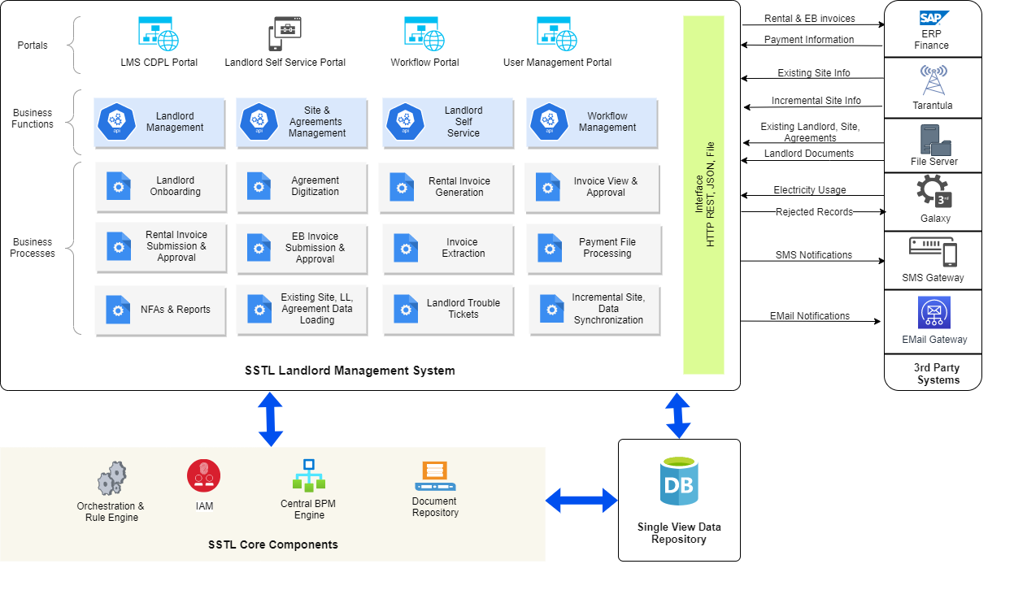

Figure - Solution Diagram for Crest LMS Implementation

All the components in each layer are interoperable with each other and the solution being cloud agnostic, enables organizations to deploy the entire system on the preferred cloud service providers or host privately. The micro service nature of the entire platform makes sure maximum uptime while reducing the possibility of a mass outage. With automated monitoring and logging functionality each event and operation performed on the platform is logged instantly.

Overall Solution Overview refers to and illustrates how the overall solution integrates and utilizes the broad functionality and realization of the proposed solution. Our Architecture principles are to support critical and major processes like Landlord Onboarding, Agreements Digitization, Invoice Management, and Approval Process management excellence. However, our solutions are multi-cloud, flexible, customer-focused, rapidly scalable, digitally-driven, secured, platform-independent, and future extensibility.

# **Solution Components**

Following are the main components of the proposed solution.

# **Landlord Self Service Portal**

Landlord self-service portal empowers landlords / vendors to have control over their relationship with CDPL. Access to the portal is shared with landlords via an automated email or SMS (will be implemented in 2nd phase) with credentials to landlords when they are on-boarded and approved. They can view their profile and additional information, site details and agreements. They can lodge complaints, view past complaints status as well as provide rating and feedback on the closed complaints. They can upload and view documents like Identity, Financial or Ownership documents. Uploaded documents, by landlord, will get updated/ rejected post validation by CDPL.

# **Landlord CDPL Portal**

Landlord CDPL portal provides 360̊ unified view of sites, landlords and agreements. Its intuitive UI provides both map and list view of sites, landlords and a central console to manage and monitor relationship between them, making operations straightforward and easy. It can be used to centrally manage (upload, view, delete) documents for sites (Site Engineering Drawing, Agreements etc.) and Landlords (Identity documents, Land records, Property documents, Bank details) etc. CDPL users can create sites and landlords and associate them. They can also digitize and store agreements against the landlord and sites. Users can upload landlord rental and EB invoices as well as perform audit and validation of generated invoices. Viewing of different reports and processing of invoice data is done from this portal.

# **Workflow Web Application**

Also known as Field Force portal comes with the SSTL Enterprise BPM engine. This portal provides all workflow related functionalities. It has both desktop and mobile friendly GUI. Can be used to launch tickets, monitor tickets, and execute tasks. It can be also used to reassign users to tasks. Enter data and upload supporting documents for task execution. View uploaded documents and entered data. It provides a utility to scan bar codes.

# **User Management Portal**

User management portal comes with SSTL AIO Access and Identity Management module. Allows configuring users, define and associate skills and associate users with different roles. Based on the roles assigned users will have access to functionalities of the application. It allows integrating with third party SSO providers supporting Open IDP or LDAP. Crest currently does not have any SSO provider.

# **API Integration and Orchestration Platform**

SSTL-AIO is a low-code middleware platform with API, Rules, and Integration and Process Orchestration functions to ease the digital transformation journey. It comes with the right set of tools and capabilities in a single package to make the business more responsive to change. Our platform can connect & integrate with all type of data sources through easy configuration making day-to-day management much easier.

SSTL-AIO is an Integration, Orchestration and API Platform. It allows the integration of disparate applications through configuration. It implements integration projects faster, safely, and economically. It acts as an API gateway for the legacy apps and helps protect legacy investments. It provides agility to the business by connecting and coordinating applications and data on premise as well as in the cloud.

# **Enterprise BPM**

SSTL Enterprise BPM engine is a no-code Workflow Engine that collaborates with the Business, IT and Field teams over a single SaaS platform and allows defining process templates on the fly and executing and monitoring them in real time. This not only increase efficiency, but operations visibility as well, and gives full control over any business process.

# **Trouble Ticketing Platform**

SSTL Trouble Ticketing platform is built on top of the Enterprise BPM Engine enabling corporations to design and deploy dynamic incident resolution templates. It’s skill-based user allocation of incidents and mobile friendly field force application allows to co-ordinate, track & monitor and execute manual job seamlessly.

# **Solution Overview**

# **Landlord, Site and Agreement Data Fields**

The data fields to be configured in LMS for capturing and storing landlord, site and agreement data are mentioned in the Annexure A (Crest_LMS_Data_Fields_v2.0.xlsx) of this document.

**\*Note** – *Unless otherwise mentioned in this document the data fields defined in Annexure A are only for capturing, storing, and viewing information and does not have any logic associated with them. Either Mobile Number or Email address should be there but it’s not unique*

Following type of data fields in the attribute section of Landlord, Site and Agreements will be made available for configuration to capture data in attribute data entry screens.

* Checkbox type data field to support True/False type of values - A new data type named Boolean will be introduced in attribute configuration screen. User will be able to dynamically define Boolean type attributes. Boolean type attributes will be rendered in GUI as checkboxes.
* Data Field to select multiple values - A new data type named 'Multiple Selection' will be introduced in attribute configuration screen. User will be able to define multiple possible values for the data field. When rendered in the UI screen all the possible values will appear as checkboxes and user can select one or multiple. If the data field is mandatory, user needs to select at least one check box.Ei
* File Upload data fields – An option to option to upload file directly from the data entry screens will be provided. Three new data types named Image File, Text File and Custom File will be introduced in attribute configuration screen. These types of fields will be rendered in the screen with File Upload option. Files uploaded will be stored in internal DMS. Re-uploading a file will remove the old file and upload the new file. Option will be there to view the uploaded file. Files uploaded from the attributes data entry screen will also be available to view from the corresponding documents section (tab).

Additionally custom UI orchestration will be implemented in attribute data entry screens to establish dependency between fields as defined in the rules below. Dependency here means – to make one or more optional fields mandatory and visible based on the value selected for another field.

* Landlord Attributes Data Entry Screen dependencies are – ­
  + If value selected for ‘PAN Status’ attribute data field is ‘Available’ then ‘PAN’ attribute data field and ‘PAN Document’ upload file field to be made visible and mandatory, otherwise not visible.
  + If value selected for ‘MSME Status’ attribute data field is ‘Available’ then ‘MSME’ attribute data field and ‘MSME Document’ upload file field to be made visible and mandatory, otherwise not visible.
  + If value selected for ‘Additional Bank Required’ attribute data field is ‘Available’ then ‘Beneficiary Name (EB)’, ‘Bank Name (EB)’, ‘Bank Account No (EB)’ and ‘IFSC Code (EB)’ attribute data fields and ‘Cancelled Cheque (EB)’ file upload field to be made visible and mandatory, otherwise not visible.
* Site Attributes Data Entry Screen dependencies are – ­­­
  + If value selected for ‘EB Meter Status’ attribute data field is ‘SEB Meter’ then ‘Electricity Consumer No’, ‘SEB Meter Serial Number’ and ‘SD for Electricity (EB Board)’ attribute data ­field to be made visible and mandatory, otherwise not visible.
  + If value selected for ‘EB (FOC/Chargeable)’ attribute data field is ‘Chargeable’ then ‘Sanction Load’ to ‘EB Invoice Frequency’ attribute data field to be made visible and mandatory, otherwise not visible.
  + If value selected for ‘EB Meter Status’ attribute data field is ‘Sub Meter’ or ‘Prepaid Meter’ then ‘Submeter Serial Number’, ‘EB Meter Installation Charges (Fixed)’ and ‘SD for Electricity (Realtor)’ attribute data field to be made visible and mandatory, otherwise not visible.
* Agreement Attributes Data Entry Screen dependencies are –
  + If value selected for ‘Rent Status’ attribute data field is ‘FOC’ then ‘RENT’ & ‘REN ESCALATION’ attribute data field not to be made visible, otherwise will visible and mandatory.
  + If value selected for ‘Escalation Basis’ attribute data field is ‘Not Applicable’ then ‘Rent Escalation Frequency’, ‘Rent Escalation Start Date’ & ‘Rent Escalation Rate (in %)’ attribute data field not to be made visible, otherwise will visible and mandatory.
  + If value selected for ‘EMD’ attribute data field is ‘Applicable’ then ‘EMD Amount’ attribute data field to be made visible and mandatory, otherwise not visible.
  + If value selected for ‘BG’ attribute data field is ‘Applicable’ then ‘BG Period’ and ‘BG Claim Period’ attribute data fields to be made visible and mandatory, otherwise not visible.
  + If value selected for ‘Security Deposite’ attribute data field is ‘Applicable’ then ‘Security Amount Basis’,’Security Deposit Applicable’, ‘Security Deposite Month’, ‘Security Deposit Amount’,’Security Deposit Date’,’SD Escalation frequency’,’SD Escalation Rate (in %)’,’SD Escalation Start Date’ attribute data fields to be made visible and mandatory, otherwise not visible.
  + If value selected for ‘Security Amount’ basis attribute data field is ‘Fixed’, then ‘Security Deposit’ applicable, ‘Security Deposit Minth’, ’SD Escalation frequency’, ’SD Escalation Rate (in %)’,’SD Escalation Start Date’ attribute data fields to be made visible and mandatory, otherwise not visible.
  + If value selected for ‘Space Charges’ attribute data field is ‘Applicable’ then ‘Space Charges Type’, ‘Space Charges Amount’, ‘Space Charge w.e.f.’, ‘Additional Space’, ‘Space Charges Escalation frequency’, ‘Space Charges Escalation Rate (in %)’, ‘Space Charges Escalation Start Date’ attribute data fields to be made visible and mandatory, otherwise not visible.
  + If value selected for ‘Space Charges Frequency’ attribute data field is ‘Fixed’ then, ‘Additional Space’, ‘Space Charges Escalation frequency’, ‘Space Charges Escalation Rate (in %)’, ‘Space Charges Escalation Start Date’ attribute data fields to be made visible and mandatory, otherwise not visible.
  + If value selected for ‘Maintenance’ attribute data field is ‘Applicable’ then 'Frequency of Manintenance Charges', 'Maintenance Charges', 'Maintenance Charge w.e.f.', 'Maintenance Charges Escalation frequency', 'Maintenance Charges Escalation Rate (in %)', 'Maintenance Charges Escalation Start Date' attribute data fields to be made visible and mandatory, otherwise not visible.
  + If value selected for ‘Leaky Cable’ attribute data field is ‘Applicable’ then 'Frequency of Leaky Cable Charges', 'Leaky Cable Charges', 'Leaky Cable Charges w.e.f.', 'Leaky Cable Charges Escalation frequency', 'Leaky Cable Charges Escalation Rate (in %)', 'Leaky Cable Charges Escalation Start Date' attribute data fields to be made visible and mandatory, otherwise not visible.
  + If value selected for ‘Clamp Charges’ attribute data field is ‘Applicable’ then 'Clamp Charges w.e.f.', 'Clamp Charges Escalation frequency', 'Clamp Charges Escalation Rate (in %)', 'Clamp Charges Escalation Start Date' attribute data fields to be made visible and mandatory, otherwise not visible.
  + If value selected for ‘Cable Tray Charges’ attribute data field is ‘Applicable’ then 'Frequency of Cable Tray Charges', 'Cable Tray Charges', 'Cable Tray Charges w.e.f.', 'Cable Tray Charges Escalation frequency', 'Cable Tray Charges Escalation Rate (in %)', 'Cable Tray Charges Escalation Start Date' attribute data fields to be made visible and mandatory, otherwise not visible.
  + If value selected for ‘Agreement Registration’ attribute data field is ‘Applicable’ then 'Agreement Registration Amount', 'Agreement Registration Date', 'Stamp Duty Expenses borne by Landlord', 'Stamp Duty Expenses borne by Crest' attribute data fields to be made visible and mandatory, otherwise not visible.

# **Custom UI Changes**

Following changes will be made into the LMS across all UIs -

* 'Tickets' tab header label in Landlord View of CDPL portal will be changed to 'Landlord Helpdesk'.
* 'Tickets' menu label in Landlord Self Service application will be changed to 'Landlord Helpdesk'.
* Label 'Region' will be changed to 'Circle'.
* Label 'SiteCode' will be changed to 'SiteId'.
* In left tabular section of Landlord view of CDPL portal, 'Registration Date' will be replaced by 'PAN' of the landlord. Sorting functionality to work on PAN following standard ASCII value-based sorting mechanism.

# **Workgroup Role Configuration**

Main users of the system come from the following 4 departments/teams.

* Estate Management Group (EMG) – Manages Landlord relationship, validation, and submission of invoices, monitors payments, and provides support to landlord query/issues.
* Site Acquisition Team (SAQ) –Landlord onboarding, agreement management
* Finance –Invoice approvals and payments
* Legal – Agreement approval
* Landlords – View invoices, payments via landlord self-service app and raise tickets.

Accordingly, five workgroups will be created in the system and appropriate privileges will be associated with the workgroups. Respective users from the teams will be associated with the workgroups.

# **Process Implementation**

# **Landlord Onboarding Process**

Landlord onboarding process will start in LMS during the hard acquisition phase of the Site MRFAI/RFS. The site in consideration will automatically be created in LMS with minimal details via TT integration once the first operator is MRFAI on the site and signoff is received.

**\*Note** – *Site Creation functionality from LMS CDPL portal will be blocked for all users so that no site can be manually created in LMS. All Site data should flow from TT to LMS; otherwise there will be discrepancies in site data between the two systems*.

SAQ team will use the CDPL portal Site View to search using the Site ID for the Site being considered. SAQ team will select the site and manually enter the remaining details of the site to fill up all mandatory fields as required.

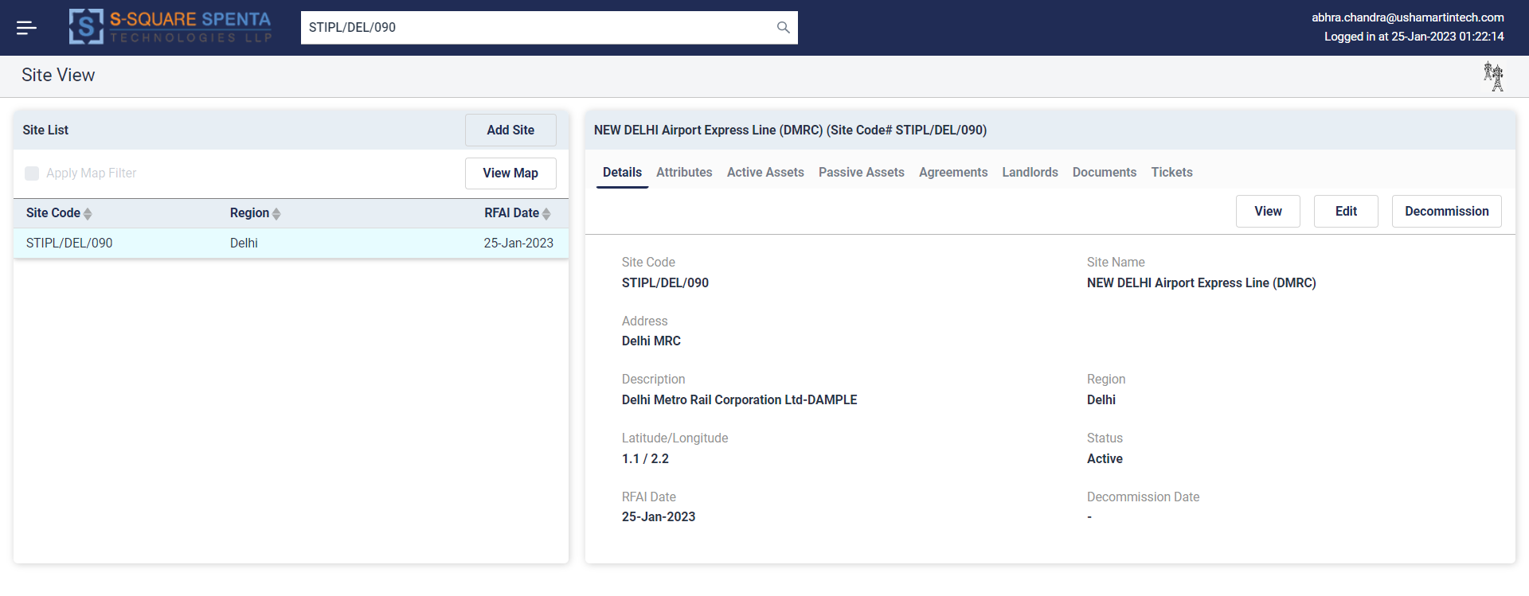

In the above screen RFAI Date will be replaced with Record creation Date. MRFAI date will be maintained OPCO wise.

Figure - Site View of LMS

SAQ team will create the landlord manually from landlord view of CDPL portal (using ‘Add Landlord’ functionality) and will enter the landlord details and upload the required documents.

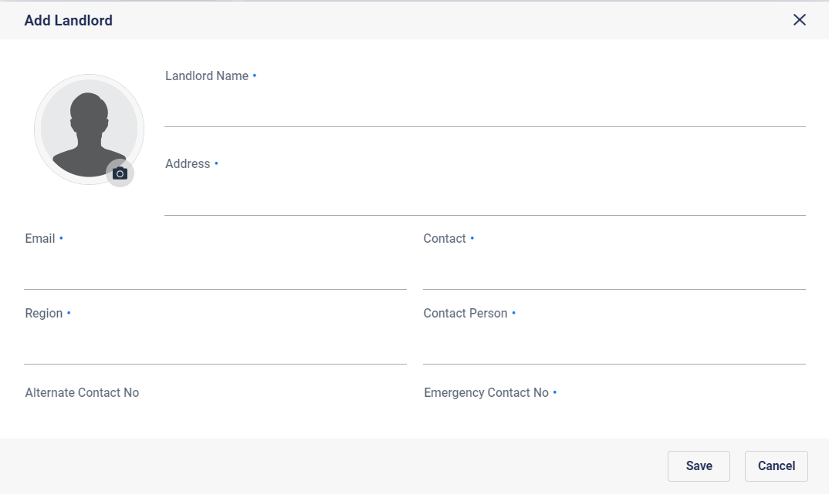

Figure - Add Landlord Dialog

Then SAQ will manually associate the landlord with the site from the Site View of the CDPL portal by first searching the site and using the ‘Add landlord to Site’ functionality in the Site-Landlord association screen. Multiple landlords can be associated with the site. Users need to mention the pay-out share during landlord association with the site. For single owner sites the payout share should be entered as 100.

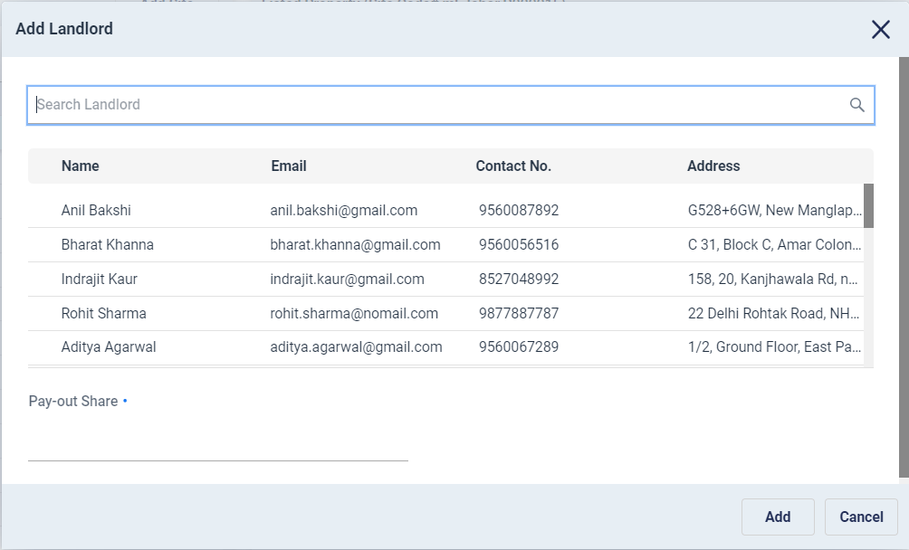

Figure - Associate Landlord with Site Dialog

An option to create the landlord manually from this association screen will be provided, so that landlords can directly be created from this screen and associated with the site in a single go.

**\*Note** – *Landlords may be created in LMS independently even before the site is created. Once the site is created (via TT integration) then the appropriate landlord can be associated with that site.*

SAQ team creates an agreement for the site manually from the Agreements tab of Site View using the ‘Add Agreement’ functionality. Uploads the agreement documents (scanned copy or image) and enters details of the agreement (all mandatory fields). The agreement will be created in Pending state.

Once the agreement is created, a workflow named “-First Documents Approval” is launched automatically and approval process is started as part of landlord onboarding.

There will be four levels of ‘verification and approval’ tasks configured in the Landlord Onboarding workflow. They are –

* Verification and Approval by Acquisition Senior Team
* Verification and Approval by Legal Team
* Verification and Approval by EMG Team
* Verification and Approval by Finance Team

Each team will be notified via Email about the approval task when the task is allocated to their bin. The email will have a link to open the approval / rejection task window. Site Id, Site Name, Address, Landlord Name, Contact Number and Agreement Documents will be visible in the task window. Additionally links to the Site View and Landlord View will be provided so that the team can view all details of the site, agreement and landlords.

User needs to accept the task first. The task window will provide an option to approve or reject along with ten reject reason selection dropdown. A few common rejection reasons as provided by Crest and mentioned in Annexure E will be populated in the reject reason drop downs. Users need to select the reject or approve option and select the rejection reasons accordingly and then save the data. Finally, the user needs to finish the task. This will remove the task from the user’s bin.

The approval process is sequential, i.e. happens one after another. If it is rejected at any level, then the complete workflow gets cancelled / rejected and intimation is sent to SAQ team (via Email) with the rejection reason. SAQ team will be able to update the agreement manually (to correct it based on rejection reason) and the “Agreement Approval” workflow will be launched automatically, and approval process will be started once again.

Only when the agreement is approved at all four levels (including final approval from Finance team) the agreement will be made ‘Active’. The newly on boarded landlord records will be sent to SAP (ERP) for Vendor code generation via integration interface (as defined in [Section 8.4](#_SAP_(ERP)_Integration_1)). Once the vendor codes are received from SAP (ERP) they are automatically updated into LMS. At the same time Welcome message is sent to the landlord via email and SMS. The welcome message will also contain the link (URL) for the landlord self-care application and user id and password to access the application.

**\*Note** – *Though Crest has decided to start landlord onboarding process in LMS during hard acquisition phase, the system can also be used to enter data for all prospective landlords and sites considered during soft acquisition phase, so that a comprehensive database of owners and properties can be maintained in LMS which will help in serving future SRs more effectively*.

**\*Note** – *Site in LMS is being created only after the first tenant is MRFAI as that is when the first NB or TI is being received from Tarantula*.

# **Agreement Management Process**

LMS allows creating and managing agreements at site level in the Site View of CDPL portal. All agreements created are in ‘Pending’ state. Once they are approved via ‘Agreement Approval’ workflow only then they become ‘Active’. LMS displays both pending and active agreements in the window. All agreements created in LMS should have a document uploaded (ideally the scanned copy of the agreement).

Agreements can be edited to change the details. Updating an agreement will launch ‘First Document Approval’ workflow automatically.

Agreements can also be deactivated which makes the agreement Inactive and it does not appear in the agreements window anymore.

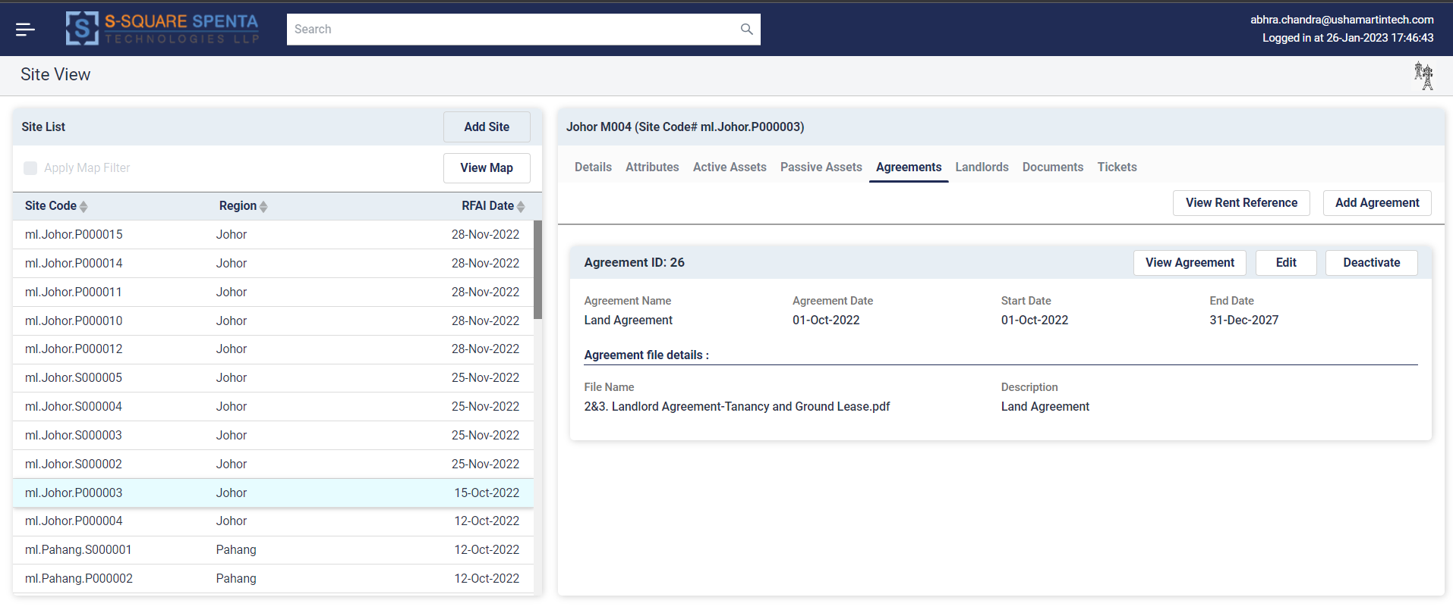

Figure - Agreements View

SSTL proposes following generic model for agreement management for all types of sites (IBS, Small cell, RTP).

* For ‘all operator agreements’ only one main agreement record will be maintained in LMS.
* For ‘per operator’ or ‘up to two / three operator’ agreements also one main agreement record will be maintained for the first or first two / three tenant (s).
* As and when new tenants are on-boarded, and payout needs to be revised new addendum agreement records with NFA, RCC & MRFAI will be created.
* This addendum agreement records can have the same agreement document uploaded or the RCC (Rent Commencement Certificate) uploaded.

This will allow maintaining tenant wise escalation date, frequency, and rate. Also, there is no need to capture all tenant details in a single agreement.

Based on the proposed solution above, LMS will allow having one main agreement and multiple addendum agreements (as required) per site. There will be no overlapping date restrictions between main and addendum agreements. During renew of existing main agreement, another main agreement needs to be created which will initially be in Pending state and moves through approval process. Once approved the new agreement becomes active. It may be possible for both the main agreements (old and renewed) to be active on the site for a period.

For example – A site has an active agreement from 1-Jan-2020 to 31-Dec-2025. Renewal process for this agreement starts on 01-Apr-2025 and finishes on 31-Oct-2025. Renewed agreement start date is 1-Jan-2026 and end date is on 31-Dec-2031. So, for the period of 1st Nov 25 to 31st Dec 25 there are two active invoices, but the agreement dates are mutually exclusive. The dates of two main agreements should not overlap.

**Agreement Renewal Reminder Process**

A backend process will be provided in LMS to automatically track and report the agreements to be expired in near future. The process will run every morning automatically. It will prepare lists of main agreements already expired, expiring in next 30 days, 31 to 90 days, 91 to 180 days and 181 to 360 days. These lists will be emailed to designated team via this process. It will consider a main agreement renewed if there is another main agreement present in the site in active state.

# **Existing Landlord, Site and Agreement Data Import Process**

SSTL LMS will provide a backend process to upload landlord data into system via excel file based interface with predefined format. Crest needs to provide the existing landlord data in required excel format. The file will be placed in a pre-configured directory (mounted or mapped directory) and the process needs to be launched manually. The process will load the data to create the landlords in the LMS after due validation. The records failed to process will be logged in a reject file for later reconciliation.

The proposed landlord data import template is mentioned in Annexure B of this document.

SSTL LMS will provide a backend process to upload site data into system via excel file based interface with predefined format. Crest needs to provide the existing site data in required excel format. The file will be placed in a pre-configured directory (mounted or mapped directory) and the process needs to be launched manually. The process will load the data to create the sites in the LMS after due validation. The records failed to process will be logged in a reject file for later reconciliation.

The proposed site data import template is mentioned in Annexure C of this document.

SSTL LMS will provide a backend process to upload agreement data into system via excel file based interface with predefined format. Crest needs to provide the existing agreement data in required excel format. Naming convention for the file is *Agreement_Import_File_<DD-Mon-YYYYHHmmSS>.xlsx*. The file will be placed in a pre-configured directory (mounted or mapped directory) and the process needs to be launched manually. The process will load the data to create the agreements and associate them with the corresponding site.

The proposed agreement data import template is mentioned in Annexure D of this document.

**Note** - To create the agreements successfully in LMS the precondition is to have the agreement soft copy file (scanned copy or image) available. Backend process will look for the agreement file in a site-specific folder as described in Section 6.3.4.4. In case the agreement file is not available or can’t be accessed then the agreement record will be rejected.

**Note** – *The order of importing data is Landlord, Site and Agreements, hence the landlord file needs to be imported first and then site file and finally the agreement file will be imported.*

All the three interface processes will implement following validations on the data set provided –

1. Files with duplicate names will be rejected.
2. Duplicate data will be rejected.
3. Data Type validation
4. Mandatory field validation
5. Data Integrity validation

All rejected records are written into separate reject file. Once processed the data import file is moved to the archive directory.

As per discussion with Crest the existing data import process needs to be run thrice during production go live. Once during production go live, and twice later (within 1 week of go live) to load the delta data generated in between.

**\*Note –** *All dates to be provided in the existing landlord, site and agreement records should be in DD-Mon-YYYY format. Examples are 01-Jan-2022 or 30-Jun-2022 etc.*

# **Existing Document Upload and Association Process**

Currently Crest maintains documents site wise and there is a folder for each site, inside which all the documents scanned copies (for that site) are kept. The scanned document files do not have proper name to identify the document type, i.e. if it is a PAN or Cancelled Cheque or any other document. Also, sometimes all the documents are scanned together to create a single file.

Crest will start scanning individual documents separately and name them following a fixed pattern (naming convention) so that the document type and document owner (landlord/site) can be identified from the name itself. For example, document names can be in following format -

* <SITE ID>#<Vendor Code>#<DOCUMENT TYPE>.pdf/jpg where DOCUMENT TYPE can be.
  + NFA
  + AGRM – Agreement
  + MOU
  + RCC – Rent Commencement Certificate
  + KYC
  + CC – Cancelled Cheque
  + PAN
  + GST
  + MRFAI
  + INV
  + MSME
  + TDS
  + ASO
  + ASL
  + EBAD
  + AFD
  + EBNOC

Crest needs to rename the existing documents following the same naming convention. There should be a directory/folder named DOCUMENT_ROOT under which the Site wise directories should be maintained. Following is a sample directory structure.

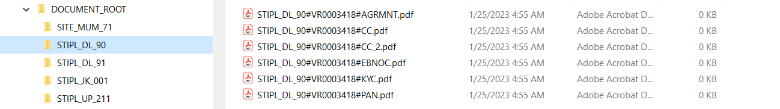

Figure - Sample proposed document organization.

LMS will provide a backend process to read from the DOCUMENT_ROOT and subsequent site wise folders/directories. The path to DOCUMENT_ROOT directory should be mapped / mounted in the process server. The process will deduce the landlord from the Vendor Code in the file name and Site from the Site name in the file name and associate the document with corresponding landlord or site. The document will be uploaded into the internal DMS. The documents thus uploaded can be viewed from Documents tabs of Site and Landlord view of CDPL portal.

If a site has multiple landlords, then the process will expect multiple documents in the site directory with different Vendor Code for different landlords.

Documents uploaded successfully will be moved away from the site directory hence only the ones which are failed to upload will remain in the site directory. This will help to troubleshoot and rerun the process multiple times without uploading duplicate documents.

Following validations will be performed while uploading a document failing any one of them will make the document rejected.

* Document naming format
* Vendor Code or Site Id must be available in LMS.
* Document size should be within configured limit.
* Document type mentioned in the file name must be recognized and supported.
* Document format (pdf/jpeg/txt) should be supported.

**\*Note –** *Crest Site Ids contain special characters which are not allowed by Windows in file / folder names.*

# **Periodic Site Data Synchronization Process**

Periodic site data synchronization process is implemented via interface integration with Tarantula. Refer to Section 8.3 for details of the integration process.

# **Rental Invoice Generation and Approval Process**

**Auto Invoice Generation Process**

Rental invoices will be auto generated for the small cell, RTP & IBS agreement based non GST landlords. An attribute named ‘Auto Rentals’ will be configured and available for Yes/No value selection. The agreements against which auto invoice needs to be generated will have value ‘Yes’ set against this attribute.

A backend server process will be scheduled to run on early morning of 1st of every month automatically. It will generate rental invoices based on the rental agreements data configuration for the small cell, RTP & IBS agreement based non GST landlords. Once the invoice generation process is complete a notification email will be sent to EMG team informing the same.

Following agreement attributes will be used for rent calculation -

* **Rent Start Date** – The date from which rent calculation starts.
* **Rent Expiry Date** – The date till which rent calculation continues. If left blank, rent calculation continues till agreement end date.
* **Rent Frequency** - (Monthly/Quarterly/Half-Yearly/Yearly) – Based on the frequency the start date and end date of the invoices will be calculated. A landlord’s next invoice is only generated after the end date of the previous invoice.
* **Rent Amount** – Amount of rent to be paid every month.
* **Auto Rentals (Yes/No)** – Decides if payout invoice to be generated for associated landlord(s) with the site the agreement is associated with.
* **Escalation Start Date** – Date from which rent escalation calculation starts.
* **Escalation Percentage** – Percentage value of the rent to be escalated.
* **Escalation Frequency** – Frequency of the escalation to happen (in years). To be selected from a dropdown list.

Following items highlight the automatic rent calculation and invoice generation process -

* For each agreement and landlord combination, fixed rent is calculated from the active agreement and an invoice is generated.
* Each invoice is identified by a unique id. A running serial number will be used for generating invoice ids. These are for internal system use.
* Each invoice will have a fixed length number (22 digits) identified as invoice no. It will be in following format -

<Landlord Id><YYYYMMDD><Invoice Id>. Landlord Id will be 6 digits left padded with 0. YYYYMMDD refers to the year, month and day of the month of the date on which the invoice is generated. Invoice Id will be 8 digits left padded with 0. This is to form a unique invoice no for the invoice generated so that it does not collide with any externally submitted invoice.

* Each invoice has a start and end date based on the frequency mentioned in the agreement.
* All invoices are generated in advance.
* During the first invoice generation against a Site-Agreement for landlord(s) the rent will be prorated based on the rent start date.
* The rent amount calculated from the agreement data is always distributed between the landlords as per their share % of rent defined in LMS.

If a site does not have any landlord associated with it, that site will not be considered for auto payout. For multiple active agreements (one main and one or more addendums) associated with a site multiple invoices will be generated. For multiple landlords associated with a site also, separate invoices will be generated for each landlord.

**Invoice View for EMG & Approval Process**

An invoice management menu option will be provided in LMS. All the invoices generated across sites (for small cell agreement-based auto rentals) will be visible from this screen. There will be filtration option based on Site Id, Invoice Id, Invoice No., SAP Vendor Code, Invoice status and Invoice generation date range.

Following data fields will be presented in tabular view –

* **Site Id** – Identifier for the site for which this invoice is generated. To be auto populated.
* **Circle** – Circle of the site for which this invoice is generated. To be auto populated.
* **Site Name** – Name of the site for which this invoice is generated. To be auto populated.
* **Landlord Name** – Name of the landlord for which this invoice is generated. To be auto populated.
* **SAP Vendor Code** – SAP vendor code for the landlord for which this invoice is generated. To be auto populated.
* **Landlord Rent Share %**- Percentage of Rent share of the landlord from the site, in case of multiple landlords associated with the site. To be auto populated.
* **Solution Type** – As defined in the Site data field with the same name. Auto Populated.
* **Billing Type** – The value ‘Agreement Based’ will be auto populated.
* **Rent Status** – As defined in Agreement data field with same name. Auto Populated.
* **Type of Invoices** - The value ‘Rent’ will be auto populated.
* **Invoice Id** – Unique invoice Id generated by LMS. To be auto populated.
* **Invoice No** – Unique invoice no. generated by LMS. To be auto populated.
* **Invoice Date** – Date on which invoice is generated. To be auto populated.
* **Due Date** – Day of Month on which agreement is due as defined in Agreement data field “Payment Day of Month”. Auto populated.
* **Billing Cycle** – As defined in the Agreement data field named ‘Rent Frequency’. To be auto populated.
* **Invoice Start Date** – Start Date of the invoice in DD-Mon-YY format. To be auto populated.
* **Invoice End Date** – End date of the invoice in DD-Mon-YY format. To be auto populated.
* **Gross Amount** – Invoice Amount calculated. To be auto populated.
* **Status** – Status of the Invoice.

Possible statuses are –To be Processed, Hold by EMG, Approved by EMG, Rejected by Finance, Approved by Finance, Sent to SAP, Payment Record Received.

There will be an option in the screen to select one or multiple invoice records (checkbox-based selection). EMG team can select one or multiple invoice record and mark them as Hold by clicking a button named ‘Hold’. Entering remark against each invoice being hold is mandatory. This will change the status of the invoice from New to Hold. EMG team will also be able to un-hold a hold invoice (by clicking a button named ‘Unhold’) which will again change the invoice status to ‘To be Processed’.

EMG team can select one or more ‘To be processed’ invoices and send to Finance by clicking ‘Approve’ button. Invoices once approved by EMG cannot be further hold by EMG.

EMG team will also be able to view the invoices rejected by Finance team along with the comments entered. EMG team will be able to re-approve or hold the rejected invoices. Approval & Rejection date will be also maintained in each & every process

Invoices with status ‘Approved by Finance’, ‘Sent to SAP’ or ‘Payment Record Received’ will also appear in EMG team’s invoice view, but those invoices cannot be further worked upon.

**Invoice View for Finance & Approval Process**

An invoice view option will be provided in LMS for Finance team. Auto generated invoices which are approved by EMG team will be visible from this screen. There will be filtration option based on Site Id, Invoice Id, Invoice No., SAP Vendor Code, Invoice status and Invoice generation date range.

Finance view of the auto generated invoices will include following data fields additional to that of EMG view -

* **Invoice Submission Date** - Date on which EMG has approved the invoice. To be auto populated.
* **TDS** – Drop down field with option Applicable or Not Applicable. Finance needs to manually choose from the options. Mandatory.
* **TDS%** - Percentage of Rent to be applied as TDS. Mandatory if TDS is selected as Applicable. Need to be manually entered by finance team. Once TDS % has been entered against of vendor code and invoice type then its required to auto populate in next invoice submission with editable field.

There will be an option in the screen to select one or multiple invoice records (checkbox-based selection). Finance team can select one or multiple invoice record and mark them as Rejected by clicking a button named ‘Reject’. Entering remark against each invoice being rejected is mandatory. This will change the status of the invoice from Approved by EMG to Rejected by Finance and it will disappear from Finance team’s view of the invoices.

Finance team can select one or more invoices and approve by clicking ‘Approve’ button. Invoices once approved by Finance cannot be further rejected. Approved invoices disappear from finance’s invoice view.

Invoices approved by finance will be sent to SAP automatically via SAP integration interface as mentioned in [Section 8.5](#_SAP_(ERP)_Integration_2).

# **External Invoice Submission and Approval Process**

For invoice-based sites and GST landlords, landlords submit invoices to EMG team. EMG team validates the invoices and sends for processing to Finance. Invoices submitted can be of multiple periods combined or may be for multiple sites together.

**External Invoice Entry, View & Approval Process for EMG**

A GUI screen in the invoice management menu option will be provided to enter and view external rental invoice data in LMS for approval and processing by EMG team.

All the past invoices entered and processed will also be visible from this screen. There will be filtration option based on Site Id, Invoice Id, Invoice No., SAP Vendor Code, Invoice status and Invoice submission date range.

An ‘Add’ button will be provided to EMG team to enter new invoice data. It will open a pop-up window containing following data fields to be entered by EMG team.

* **Site Id** – Identifier for the site for which this invoice is being entered. Need to be selected from a dropdown. The dropdown will list all the site ids.
* **Circle** – Circle of the site for which this invoice is being entered. To be auto populated using the Site Id.
* **Site Name** – Name of the site for which this invoice is being entered. To be auto populated using the Site Id.
* **Agreement Name** – Need to be selected from a drop down. All the active agreements (main and addendums) under the site will be listed in the dropdown. Users need to select the one against which the invoice is being booked.
* **Landlord Name** – Name of the landlord for which this invoice is being entered. Need to be selected from a dropdown. The dropdown will list all the landlord(s) associated with the site. If there is only landlord for the site, then it will be auto populated.
* **SAP Vendor Code** – SAP vendor code for the landlord for which this invoice is being entered. To be auto populated.
* **Landlord Rent Share %**- Percentage of Rent share of the landlord from the site, in case of multiple landlords associated with the site. To be auto populated.
* **Solution Type** – As defined in the Site data field with the same name. Auto Populated.
* **Billing Type** – Need to be selected from a dropdown. The dropdown will list –
  + Agreement Based
  + Invoice Based
  + NFA Based

User needs to manually select one.

* **Rent Status** – As defined in Agreement data field with same name. Auto Populated.
* **Type of Invoices** – Need to be selected from a dropdown. The dropdown will list –
  + Rent
  + Maintenance
  + Escalation
  + Rent+ Space Charges + Conservancy Fee
  + Space Charges & Conservancy Fee
  + Space Charges
  + Waiver
  + Debit Note
  + Credit Note
  + Interest Charges
  + NFA
  + SD - License Fee
  + Others
  + Advance

User needs to manually select one.

* **Invoice No** – Invoice no. to be entered manually. LMS will validate that Invoice No. should be unique for the landlord SAP vendor code for the financial year.
* **Invoice Date** – Date on which invoice is generated by Landlord. To be manually entered by selecting from a calendar date field.
* **Bill Received Date -** Date on which the invoice is received from Landlord. To be manually entered by selecting from a calendar date field.
* **Due Date As per Invoice -** Date on which the invoice is due for payment as mentioned in the invoice. To be manually entered by selecting from a calendar date field.
* **Due Date As per Agreement** – Day of Month on which agreement is due as defined in Agreement data field “Payment Day of Month”. Auto populated.
* **Billing Cycle** – As defined in the Agreement data field named ‘Rent Frequency’. To be auto populated.
* **Invoice Start Date** – Start Date of the invoice. To be manually entered by selecting from a calendar date field. Mandatory.
* **Invoice End Date** – End date of the invoice. To be manually entered by selecting from a calendar date field. Mandatory.
* **Gross Amount** – Gross Invoice Amount as per the invoice. To be manually entered. Mandatory.
* **GST%** - Applicable GST %. To be manually entered. Mandatory.
* **Invoice Amount** – Auto Calculated as Gross + GST.
* **Bill for Operator –** All active operators on the site will be listed with check box options beside them User may select one or multiple. Selection of operators is Optional.
* **Invoice Arrears -** To be manually entered. Optional.
* **Remarks –** Optional. To be manually entered.

**\*Note –** *LMS will validate the entered data for duplicate Invoice no., overlapping Invoice Period (Invoice Start and End date) for same type of invoices, i.e., Rent or Maintenance etc.*

Once an external invoice is added it is ready for processing and its status becomes ‘To be Processed’. Option will be there to edit the entered invoice data which are not processed yet. There will be an option in the screen to select one or multiple external invoice records (checkbox-based selection). EMG team can select one or multiple external invoice record and mark them as Hold by clicking a button named ‘Hold’. Entering remark against each invoice being hold is mandatory. This will change the status of the invoice from ‘To be processed’ to ‘Hold’. EMG team will also be able to un-hold a hold invoice (by clicking a button named ‘Unhold’) which will again change the invoice status to ‘To be Processed’.

EMG team can select one or more ‘To be processed’ external invoices and send to Finance by clicking ‘Approve’ button. External invoices once approved by EMG cannot be further hold by EMG.

EMG team will also be able to view the external invoices rejected by Finance team along with the comments entered. EMG team will be able to edit and re-approve or hold the rejected invoices.

External invoices with status ‘Approved by Finance’, ‘Sent to SAP’ or ‘Payment Record Received’ will also appear in EMG team’s invoice view, but those invoices cannot be further worked upon.

**External Invoice View for Finance & Approval Process**

An external invoice view option will be provided in LMS for Finance team. External invoices which are approved by EMG team will be visible from this screen. There will be filtration option based on Site Id, Invoice Id, Invoice No., SAP Vendor Code, Invoice status and Invoice generation date range.

Finance view of the external invoices will include following data fields additional to that of EMG view-

* **Invoice Submission Date** - Date on which EMG has approved the invoice. To be auto populated.
* **TDS** – Drop down field with option Applicable or Not Applicable. Finance needs to manually choose from the options. Mandatory.
* **TDS%** - Percentage of Rent to be applied as TDS. Mandatory if TDS is selected as Applicable. Need to be manually entered by finance team.

There will be an option in the screen to select one or multiple invoice records (checkbox-based selection). Finance team can select one or multiple invoice record and mark them as Rejected by clicking a button named ‘Reject’. Entering remark against each invoice being rejected is mandatory. This will change the status of the invoice from Approved by EMG to Rejected by Finance and it will disappear from Finance team’s view of the invoices.

Finance team can select one or more invoices and approve by clicking ‘Approve’ button. Invoices once approved by Finance cannot be further rejected. Approved invoices disappear from finance’s invoice view.

Invoices approved by finance will be sent to SAP automatically via SAP integration interface as mentioned in [Section 8.5](#_SAP_(ERP)_Integration_2).

# **Galaxy based Submeter Reading data Approval Process**

EB usage data from small cell sites having submeter is mainly collected via Galaxy spin app. The data will be coming to LMS via LMS Galaxy Integration interface as mentioned in Section 8.7.

LMS will provide a backend process which will automatically pull submeter reading data submitted in Galaxy, the previous day. LMS will maintain the date till which the submeter reading data has been pulled by it, so that next time the process runs it starts pulling from the day after that date.

**Submeter Reading Data View & Approval Process for EMG**

LMS will provide a GUI screen to view the galaxy spin submeter data collected and received in LMS. There will be filtration option based on Site Id and Submit date range. Following data fields will be displayed in a tabular view.

* **ActivityId –** Unique identifier maintained by Galaxy.
* **Circle -** Circle the site belongs to.
* **Site Id -** ID of the Site for which the submeter reading is taken.
* **Site Name -** Name of the Site for which the submeter reading is taken.
* **Site Type -** Type of Site for which the submeter reading is taken.
* **Submitted By -** Galaxy user name who took the submeter reading.
* **Submit Date -** Date on which the meter reading is submitted.
* **Reading Date -** Date on which the meter reading is taken.
* **Previous Reading Date -** Date on which previous meter reading was taken.
* **Sub Meter No. -** Sub meter serial number
* **Current Sub Meter Reading -** Current sub meter reading value
* **Previous Sub Meter Reading -** Previous sub meter reading value
* **Consumption -** Calculated by subtracting Previous Reading from Current Reading
* **Current Sub Meter Pic –** Clickable URL to the Sub Meter Pic. Clicking it will open a new tab with the submeter picture.
* **Current Remark –** Remarks if any

All the data displayed above will be shown as received from Galaxy, except Consumption, which is auto calculated. No data field will be editable.Beside each record a flag will be shown to indicate if the record is erroneous. A record is considered erroneous if it does not have mandatory data fields available or duplicate activity id or overlapping reading dates or current reading less than previous reading.

**\*Clarification Required** - *In case of submeter replacement in a site can the previous meter reading be less than the current meter reading? How to implement check in that case.*

In case of submeter replacement, a new meter no. will be there and the reading will start from 0 or any other number , system will keep records of previous meter no. also There will be an option in the screen to select one or multiple submeter reading records (checkbox-based selection). EMG team can select one or multiple records and reject them by clicking a button named ‘Reject’. Entering remark against each invoice being rejected is mandatory. LMS will call Galaxy API synchronously to reject the records in Galaxy too via LMS Galaxy integration interface API as mentioned in Section 8.7.

EMG team can select one or more submeter reading records and send to Finance by clicking ‘Approve’ button. EB submeter reading records once approved by EMG cannot be further rejected by EMG.

Submeter readings approved by EMG team is automatically converted into EB invoices. Following are the values for some key invoice fields–

* + **Billing Type – ‘**Galaxy Based’ will be auto populated.
  + **Type of Invoices – ‘**EB’ will be auto populated.
  + **Invoice No –** Automatically generated by combining ActivityId and Site Id and Submission Date.
  + **Invoice Date –** Current date
  + **Bill Received Date –** Meter reading submission date.
  + **Meter Type –** ‘Sub Meter’ will be auto populated.
  + **Invoice Start Date –** Previous Meter Reading Date
  + **Invoice End Date –** Current Meter Reading Date
  + **Opening Reading –** Previous Meter reading
  + **Closing Reading –** Current Meter reading
  + **EB Amount -** The invoice amount is calculated using the site level attribute data field named “Electricity Unit Rate for Submeter” value multiplied by consumption units.

These invoices are auto populated in the EB invoice view screen, from where EMG team can review them and approve or hold as required. These invoices are processed in the same way external EB invoices are processed.

# **EB Invoice Submission and Approval Process**

For IBS and Metro sites EB invoice is submitted by realtors to EMG team. EMG team validates the EB invoices and sends for processing to Finance. EB Invoices submitted can be of multiple periods combined or may be for multiple sites together.

**EB Meter information maintenance in LMS**

LMS needs to store and maintain the details of EB meters installed at a site, so that the external invoices or Galaxy meter reading data can be validated against those meter serial numbers. LMS will provide a screen in the Site view of LMS to capture and view/modify EB meters associated with a site. Following meter details will be captured. Maintaining multiple meter records against a site will be possible.

* EB Meter Category – Dropdown with three values –
  + SEB Meter
  + Sub Meter
  + Prepaid Meter
* Meter Serial Number
* Consumer No. – Only for SEB meter
* SEB Meter Installation Date – Only for SEB meter
* SEB Authority Name – Free-flow text entry. Only for SEB meter.

**\*Note** – *In case a site is FOC for EB charges then that will be captured via a Site level data field. In that case no meter record will be maintained against the site.*

**EB Invoice Entry, View & Approval Process for EMG**

A GUI screen in the invoice management menu option will be provided to enter and view external EB invoice data in LMS for approval and processing by EMG team.

All the past EB invoices entered and processed will also be visible from this screen. There will be filtration option based on Site Id, Invoice Id, Invoice No., SAP Vendor Code, Invoice status and Invoice submission date range.

An ‘Add’ button will be provided to EMG team to enter new invoice data. It will open a pop-up window containing following data fields to be entered by EMG team.

* **Site Id** – Identifier for the site for which this invoice is being entered. Need to be selected from a dropdown. The dropdown will list all the site ids.
* **Circle** – Circle of the site for which this invoice is being entered. To be auto populated using the Site Id.
* **Site Name** – Name of the site for which this invoice is being entered. To be auto populated using the Site Id.
* **Agreement Name** – Need to be selected from a drop down. All the active agreements (main and addendums) under the site will be listed in the dropdown. Users need to select the one against which the invoice is being booked.
* **Landlord Name** – Name of the landlord for which this invoice is being entered. Need to be selected from a dropdown. The dropdown will list all the landlord(s) associated with the site. If there is only landlord for the site, then it will be auto populated.
* **SAP Vendor Code** – SAP vendor code for the landlord for which this invoice is being entered. To be auto populated.
* **Solution Type** – As defined in the Site data field with the same name. Auto Populated.
* **Billing Type** – Need to be selected from a dropdown. The dropdown will list –
  + Agreement Based
  + Invoice Based
  + NFA Based
  + Galaxy Based

User needs to manually select one.

* **Type of Invoices** – Need to be selected from a dropdown. The dropdown will list –
  + SD - EB
  + Others
  + Advance
  + EB
  + FCU
  + DG
  + EB+FCU
  + EB+DG
  + EB Fixed Charges

User needs to manually select one.

* **Invoice No** – Invoice no. to be entered manually. Invoice No. should be unique for the landlord SAP vendor code for the financial year.
* **Invoice Date** – Date on which invoice is generated by Landlord. To be manually entered by selecting from a calendar date field.
* **Bill Received Date -** Date on which the invoice is received from Landlord. To be manually entered by selecting from a calendar date field.
* **Due Date As per Invoice -** Date on which the invoice is due for payment as mentioned in the invoice. To be manually entered by selecting from a calendar date field.
* **Billing Cycle** – Dropdown to be selected manually. Drop down to list following values –
  + Annually
  + Quarterly
  + Monthly
  + By Monthly
* **Meter Type** – Dropdown to be selected manually. Drop down to list following values –
  + SEB Meter
  + Sub Meter
  + Prepaid Meter
* **Meter No**. – Dropdown showing list of available meter nos. against the site id. To be manually selected.
* **Consumer No**. - Auto populated if meter type is SEB meter, based on the data available for Site.
* **Sanction Load** - Auto populated as per data available at Site level for Site Attribute data field named “Sanction Load”.
* **Invoice Start Date** – Start Date of the invoice. To be manually entered by selecting from a calendar date field. Mandatory.
* **Invoice End Date** – End date of the invoice. To be manually entered by selecting from a calendar date field. Mandatory.
* **No**. **Of Days** – Auto calculated from End date and Start Date.
* **Opening Reading –** PreviousMeter Reading. To be manually entered.
* **Closing Reading –** Current Meter Reading. To be manually entered.
* **Reading based Consumption –** Auto calculated.
* **Manual Consumption –** Only shown when either Opening Reading or Closing Reading or both are not available. To be manually entered.
* **Per Day Consumption –** Auto calculated by dividing Reading based Consumption or Manual Consumption (if entered) by No. Of Days.
* **EB Amount** - Manually entered.
* **Unit Rate –** Auto calculated by dividing EB Amount with Reading based Consumption or Manual Consumption (if entered).
* **Fix load Charges –** To be manually entered.
* **DG Charges -** To be manually entered. Only to be shown if ‘Type of Invoice’ data field value is ‘EB+DG’ or ‘DG’.
* **FCU Charges -** To be manually entered. Only to be shown if ‘Type of Invoice’ data field value is ‘EB+FCU’ or FCU.
* **LPSC -** To be manually entered.
* **Arrear -** To be manually entered.
* **Total -** To be manually entered.
* **Fix/Load/PPAC/Other Charges –** To be auto calculated. Total - EB Amount - Fix load Charges - DG Charges - FCU Charges – LPSC – Arrear.
* **GST%** - Applicable GST %. To be manually entered. Mandatory.
* **Invoice Amount** – Auto Calculated as Total + Total * GST%
* **LPSC Payable (Yes / No) –** Dropdown to select if LPSC is payable or not.
* **Final Payable Amount -** Invoice Amount + LPSCif LPSC is payable otherwise Invoice Amount.
* **Bill for Operator –** All active operators on the site will be listed with check box options beside them User may select one or multiple. Selection of operators is Optional.
* **Remarks –** Optional. To be manually entered.

**\*Note –** *LMS will validate the entered data for duplicate Invoice no., overlapping Invoice Period (Invoice Start and End date) or meter reading nos. for a particular meter serial no.*

Once an EB invoice is added it is ready for processing and its status becomes ‘To be Processed’. Additionally, the EB invoices generated by approving galaxy meter readings are also populated in this screen with status ‘To be Processed’. Option will be there to edit the entered invoice data which are not processed yet. There will be an option in the screen to select one or multiple EB invoice records (checkbox based selection). EMG team can select one or multiple EB invoice record and mark them as Hold by clicking a button named ‘Hold’. Entering remark against each EB invoice being hold is mandatory. This will change the status of the EB invoice from ‘To be processed’ to ‘Hold’. EMG team will also be able to un-hold a hold invoice (by clicking a button named ‘Unhold’) which will again change the invoice status to ‘To be Processed’.

EMG team can select one or more ‘To be processed’ EB invoices and send to Finance by clicking ‘Approve’ button. EB invoices once approved by EMG cannot be further hold by EMG.

EMG team will also be able to view the EB invoices rejected by Finance team along with the comments entered. EMG team will be able to edit and re-approve or hold the rejected invoices.

EB invoices with status ‘Approved by Finance’, ‘Sent to SAP’ or ‘Payment Record Received’ will also appear in EMG team’s invoice view, but those invoices cannot be further worked upon.

**EB Invoice View for Finance & Approval Process**

An EB invoice view option will be provided in LMS for Finance team. EB invoices which are approved by EMG team will be visible from this screen. There will be filtration option based on Site Id, Invoice Id, Invoice No., SAP Vendor Code and Invoice date range.

Finance view of the EB invoices will include following data fields additional to that of EMG view -

* **Invoice Submission Date** - Date on which EMG has approved the invoice. To be auto populated.
* **TDS** – Drop down field with option Applicable or Not Applicable. Finance needs to manually choose from the options. Mandatory.
* **TDS%** - Percentage of Rent to be applied as TDS. Mandatory if TDS is selected as Applicable. Need to be manually entered by finance team.

There will be an option in the screen to select one or multiple EB invoice records (checkbox based selection). Finance team can select one or multiple EB invoice record and mark them as Rejected by clicking a button named ‘Reject’. Entering remark against each invoice being rejected is mandatory. This will change the status of the EB invoice from ‘Approved by EMG’ to ‘Rejected by Finance’ and it will disappear from Finance team’s view of the invoices.

Finance team can select one or more EB invoices and approve by clicking ‘Approve’ button. EB invoices once approved by Finance cannot be further rejected. Approved EB invoices disappear from finance’s invoice view.

EB invoices approved by finance will be sent to SAP automatically via SAP integration interface as mentioned in [Section 8.5](#_SAP_(ERP)_Integration_2).

# **Payment Data Upload Process**

LMS will provide with an interface process to upload payment data into system via file-based interface with SAP (ERP).

Refer to [Section 8.6](#_SAP_(ERP)_Integration) for integration interface details.

Once the successful payments are uploaded into system email/SMS notification will be sent to landlords. Email is sent to EMG via group email / distribution list.

The payment file will also contain the bounce / failure payment records with failure reason. Those records will be sent to the EMG team via email notification included in the email body. A single email will be sent with all the bounce/failure payments received per file.

The successful payments uploaded in LMS successfully can be viewed in CDPL and Landlord Self Service portal against the corresponding landlords.

# **Landlord Self Service Application**

Landlord Self Service application can be accessed via an URL and it is mobile friendly. Landlords need to use their SAP vendor code to log into the self-care portal.

Once a landlord is on boarded and SAP vendor code is generated a welcome email / SMS is sent to landlords with the login credentials and the app link (URL). After first time login the landlord will be prompted / forced to change the system generated password.

Landlords will be able to view only following sections of the application –

* Profile (Basic and Additional Info)
* Site Details, Invoices & Payments
* Tickets
* Documents

Agreement, tenant details and site level documents are not required to be displayed to landlords and those menus will be made invisible. All the data fields in the profile section will be read only for landlords. Landlords will not be able to change any data as well as upload/delete any document from the document section.

# **Landlord Information Update process**

To request change in any basic or additional information in the profile section, landlord needs go via the trouble ticket route. A special ticket named ‘Landlord Info Change Request’ will be created. This ticket can be raised by the landlords or by EMG team on behalf of the landlord. Landlord will have option to enter a remark (to mention the change request) and supporting documents (if any). The ticket will be assigned to EMG team for review. EMG team may review the request and if approved change the respective data field(s) from the landlord screen of LMS. Otherwise, they may choose to reject the ticket with proper reason and do not do any change. Landlord will be able to view the status of the ticket and remark entered by the EMG team.

# **Trouble Ticketing**

LMS Landlord Self Service application provides option to raise trouble tickets. A few types of trouble tickets will be configured for landlords to create from Self-service application when they want to report any issue or have any query to be clarified.

 

Figure - Tickets View & New Ticket Creation Window

Same trouble ticket can be raised from CDPL portal by EMG team on behalf of landlords from Landlord view.

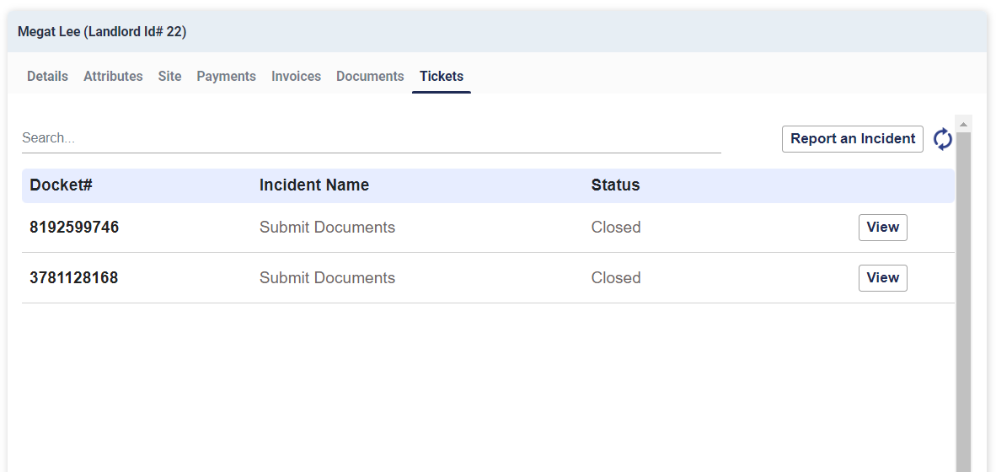 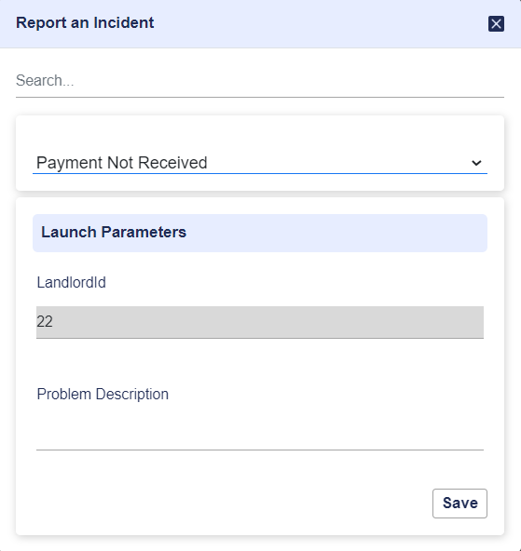

Figure - Tickets view from LMS and ticket creation window

Following five types of trouble tickets will be configured in LMS for landlord support.

* Agreement – To raise any agreement related issue, i.e. ownership change request.
* Financial Issues or Queries – To raise any finance related issue, i.e. Maintenance Payment.
* Operations Issues or Queries – To raise any operational issue, i.e. safety related questions.
* Project Vidyut – Own EB connection related
* Others – Any other issues or queries

\***Note** – *Instead of having a single trouble ticket type it is better design to have the category wise tickets which allows better management and organization of tickets and if required category wise allocation to different teams or to different members within a team will be possible. As the number of categories is limited, numbers of ticket is also limited and easier for landlords to operate. Also it will help in collecting statistics (if require) of tickets based on category.*

Following data fields will be configured in the trouble ticket so that the person raising a ticket is able to fill them up.

* **Sub category** – To be selected from a list of values from a drop down. Mandatory. The sub categories lists are different for each type of trouble tickets. Type wise list of sub categories as provided by Crest is mentioned in Annexure F.
* **Remarks** – Text to be entered describing the issue or query. Mandatory. Max 500 characters.
* **Supporting Document** – Image or document to be uploaded as supporting document. Optional.

Each type of trouble ticket will have a single resolution task named ‘Landlord Support Activity’ which will be assigned to EMG team. EMG team will be notified via Email about the Landlord Support task when the task is allocated to their bin (trouble ticket is raised). The email will have a link to open the task window. Landlord Id, Landlord Name, SAP Vendor Code, Landlord Address, Contact Number will be visible in the task window. The subcategory, remarks and the document uploaded by the landlord during ticket creation will also be visible. Additionally links to the Landlord View will be provided so that the team can view all details of the landlord.

User needs to accept the task first and manually resolve the issue. The task window will provide option to the EMG team for entering comments and upload a supporting document. Then save the data. User may also change the subcategory of the ticket based on their better understanding of the issue. Finally, the user needs to finish the task. This will remove the task from the user’s bin and close the ticket.

Landlord will be able to view the comments entered and document uploaded by EMG team from the tickets view of the self-service app.

\***Note** – *For each query or issue, landlord needs to raise separate tickets.*

# **Reports**

Following reports will be provided which can be downloaded via CDPL portal Report utility. LMS provides option to download reports in PDF and Excel format. Reports can be opened in HTML format also.

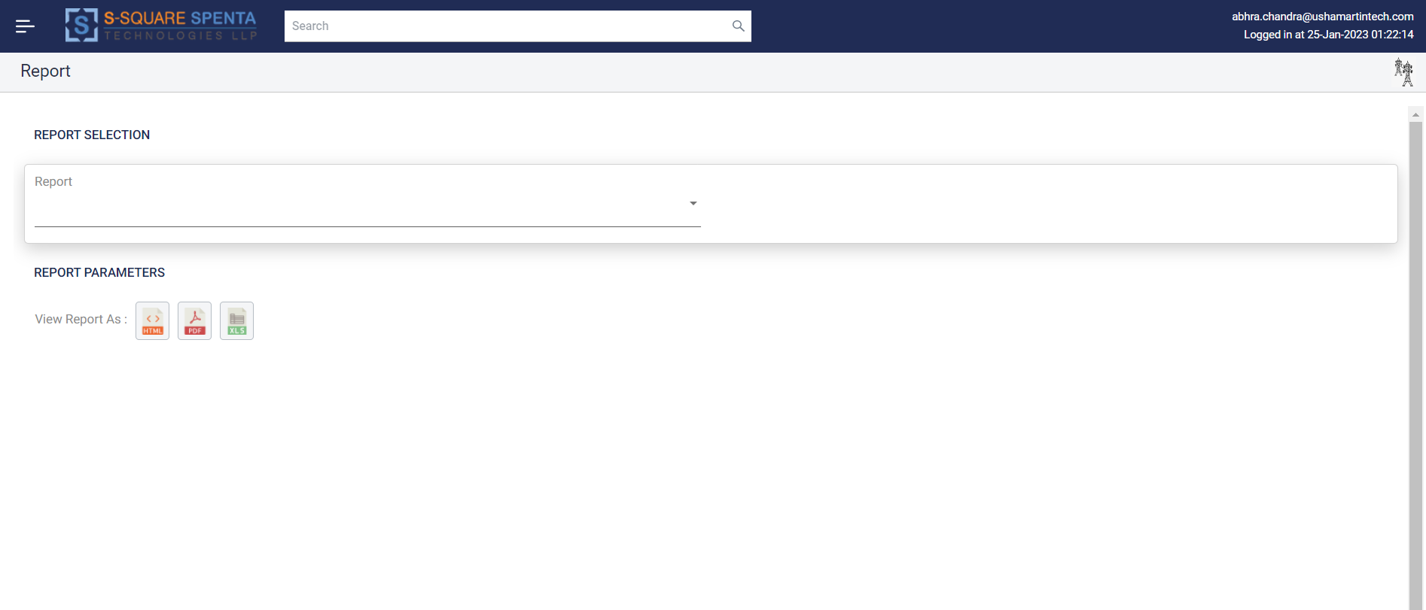

Figure - Report View Window

# **Invoice Pendency Report**

This report will provide the site and landlord wise details of the periods for which the rental invoices have not been processed yet.

* **Input** – Date Range (Start and End Date)
* **Validations** – End Date cannot be less than Start Date and End Date cannot be greater than current date. While fetching, maximum one year of the data can be fetched in one go.
* **Processing Logic** – All sites along with the missing invoice periods (for any specific landlords) for which there are no invoice records available in LMS between the date range provided.
* **Output** – Site Id, Site Name, Circle, Type of Lease Premises Landlord Id, Landlord Name, Vendor Code, Invoice Type (Rental/EB), Invoice Frequency, Missing Invoice Period in tabular format. There can be multiple records for one Site Id if invoices for multiple periods are not processed.

# **Landlord Ledger Report (Invoice & Payments)**

This report will provide the landlord wise details of the invoices and payments together.

* **Input** – Landlord Id
* **Validations** – Landlord Id entered should be numeric and should exist in LMS.
* **Processing Logic** – All Invoices and Payments for the landlord are retrieved and shown order by processing date in ascending order.
* **Output** –
  + For invoice records - Site Id, Site Name, Invoice No, Invoice Period, Invoice Date, Invoice Amount, GST, Total Amount, Invoice Type (Rental/EB/Maintenance etc.), Invoice Status (Approved/Rejected/Hold/Paid etc.), Remarks (if any)
  + For payment records - UTR No., TDS, Payment Amount, Payment Date, Remarks (if any)

# **Site Data Dump**

This report will provide details of all sites in the system.

* **Input** – None
* **Validations** – None
* **Processing Logic** – All site details will be retrieved.
* **Output** – Tabular view of all site data records containing all the site level data fields as defined in Annexure A.

# **Site - Landlord Data Dump**

This report will provide association details of sites with landlords along with landlord details for all sites in the system.

* **Input** – None
* **Validations** – None
* **Processing Logic** – All site details will be retrieved along with associated landlord details.
* **Output** – Tabular view of all landlord data records associated with the site containing all the landlord data fields as defined in Annexure A along with Site ID and Site Name.

# **Site - Agreement Data Dump**

This report will provide agreement details of sites for all sites in the system.

* **Input** – None
* **Validations** – None
* **Processing Logic** – All agreement details will be retrieved along with associated site details.
* **Output** – Tabular view of all agreement data records associated with the site containing all the agreement data fields as defined in Annexure A along with Site ID and Site Name.

# **NFA**

Crest uses NFA process for hierarchical approval in case of deviation from standard operating procedures. For example - if rent needs to be paid to a realtor even before site MRFAI or for incorporating special conditions or clauses in rental agreement, approval process needs to be triggered and approval needs to be obtained.

Enterprise BPM engines Workflow management system will be used to design template for 3 to4 NFA approval process flow. Each of the templates may have different data fields & document entry forms as required by Crest. It will also be possible to amend those templates in future to add new data fields. It will also be possible for Crest to define and deploy new NFA templates altogether with required data fields. The NFA workflow templates will have max ten levels of approval hierarchies.

The initiator need to choose one of the NFA template and will have capabilities to select one or more approvers for the NFA during initiation of the NFA. The initiator will be able to upload documents and manually enter remarks and value for other data fields (as defined in the NFA form template).

Once the NFA workflow is launched it will be assigned to the first approver (Approver 1). Each approver will have option to view the Remark and other data fields entered and the documents uploaded. Also they will be able to approve or reject the NFA and enter corresponding comment. Approvers will be able to enter their remarks and upload a document.

If approved by an approver it moves to the next level of approver. If rejected by an approver then the whole NFA workflow instance is rejected or cancelled. The NFA is deemed approved only when all the approvers approve.

Approver may also choose to request the initiator for resubmission of documents. In that case the task is reassigned to the initiator who can again resubmit the document or remark and start the approval process. At the same time the initiator can also change the earlier selected approvers.

One approver may also add other approvers for additional review. The task gets assigned to the additional reviewer and the same document and remark can be viewed by the additional approver. The additional approvers added will also have the same options of Approve/Reject/Request for Resubmission. If the additional approver asks for resubmission, the task is assigned back to the initiator. Initiator may change the approver list and may also include the additional approver. If the additional approver rejects, then the NFA is completely rejected. If the additional approver approves then the task is assigned back to the original approver (who added the additional approver). The original approver will have option to approve or reject. In case approved it flows to next approver level. If rejected the NFA is completely rejected.

Each approver can add maximum one additional approver. The additional approvers can not add any approver.

Each NFA created will have a unique docket number assigned.

A basic report needs to be provided for NFA. The report will show the NFAs initiated between a date range, with details like NFA Docket No, NFA type, initiator name, start date and status

**\*Note –** *Risk of having end user defined approvers – If initiator is allowed to select approver, it may randomize the approval process and may potentially violate organization requirements and hence the same may be reviewed.*

Following diagram depicts a NFA with three initial approvers and one additional approver added by the first approver.

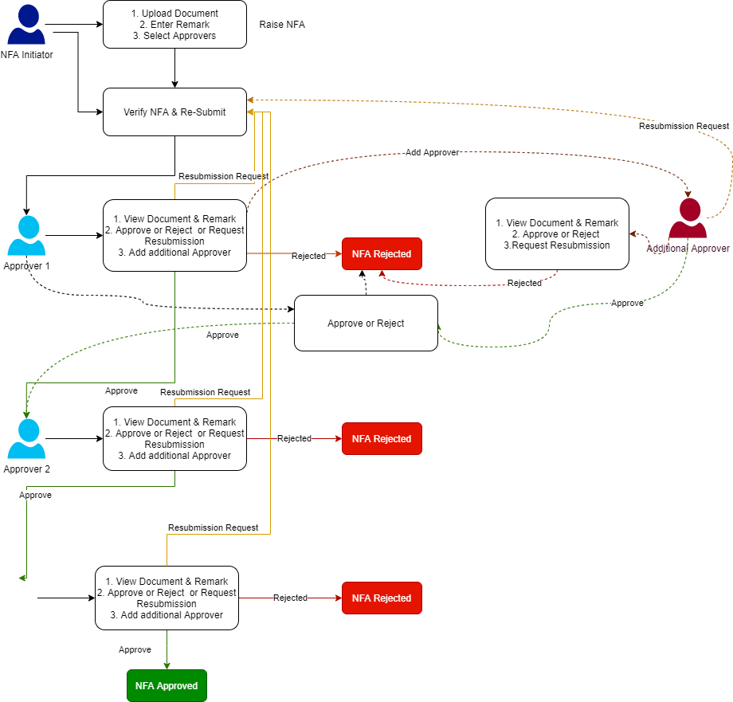

Figure - Sample NFA Flow showing 3 levels of approval and approver 1 adding additional approver

# **Design Details**

# **System Architecture**

Following is the generic architectural plan based on the high level design of the landlord management system.

# **Solution Schematic**

Following is a solution schematic diagram with main functional components of the system.

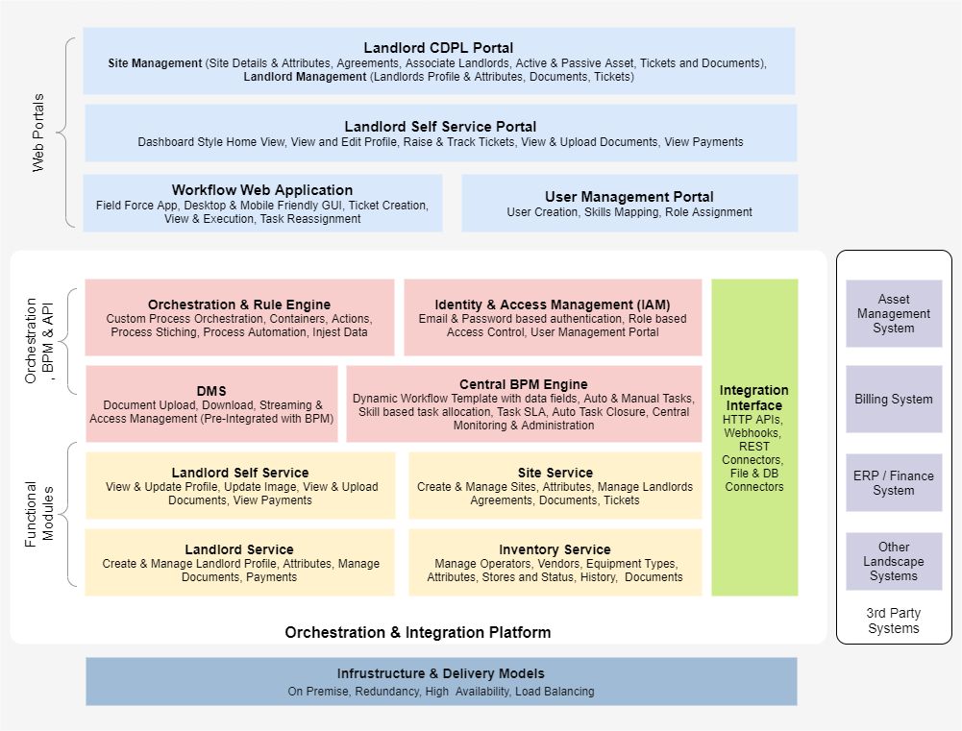

Figure - LMS Solution Schematic

# **Solution Schematic with Data Flow**

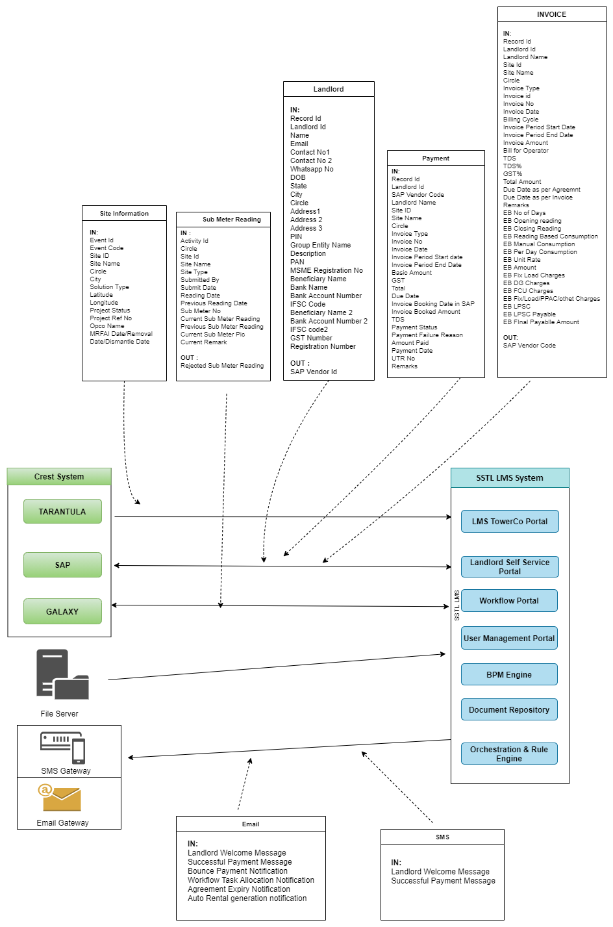

Figure - Solution Schematic with Data flow

# **Main Design Feature**

* API first design
* JSON is first class citizen.
* REST API Endpoints
* Request /Response View model pattern for communication
* Domain driven design
* Micro services Architecture
* Data source agnostic design
* Document storage is Object storage.
* Cloud Ready - Deployed on the cloud or on premise.
* Scalable architecture

# **Deployment Architecture**

The following highlights the deployment Architecture in SSTL environment for UAT & Production.

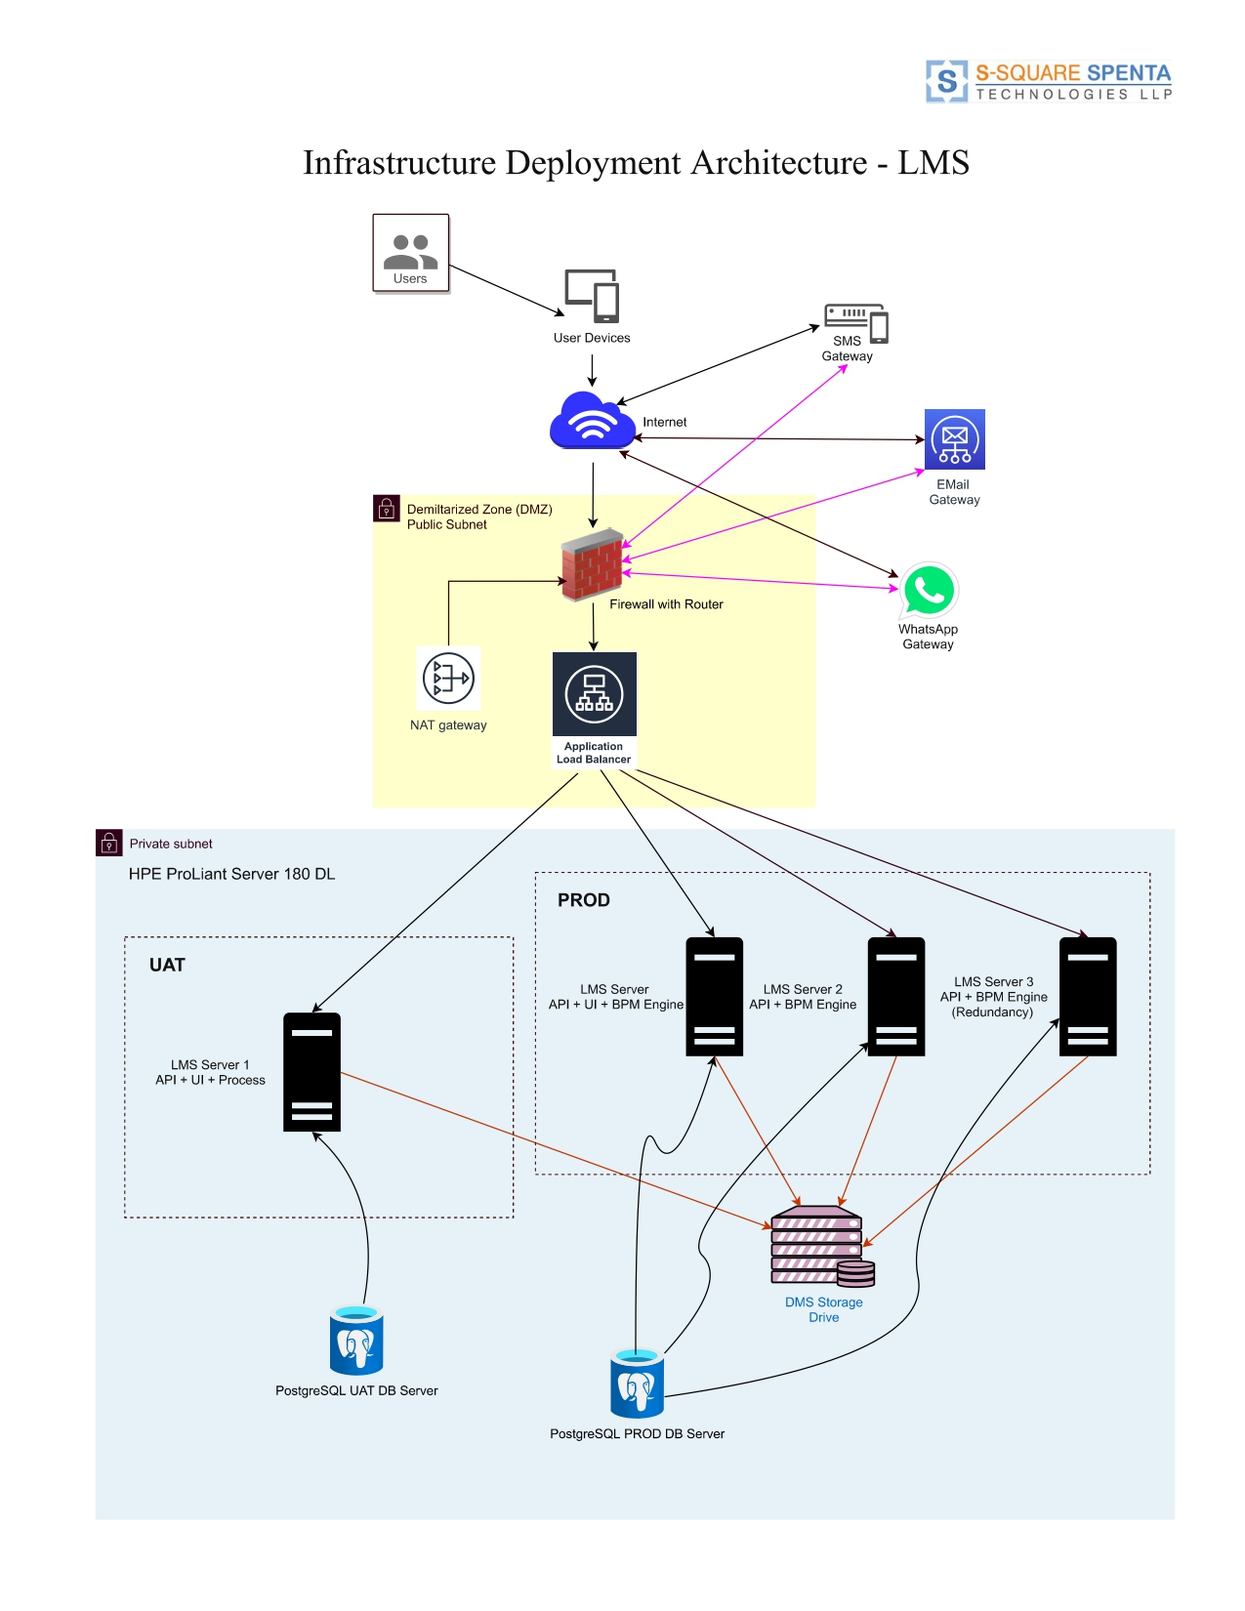

Figure 13 - LMS environment deployment diagram

# **Integration Interfaces**

# **Email Gateway**

SMTP based interface with an email gateway will be implemented to send automatic email notifications for following events –

* Landlord Welcome Email with Self Service application link, user id and password
* Agreement Expiry Email notification to EMG team
* Notification on those sites where MRFAI has been done but Agreement has not been activated.
* Auto Rental Invoice generation process completion notification to EMG team
* Bounce Payment Email notification to EMG team
* Successful Payment notification to Landlords
* Alarm emails for integration failure and other issues
* Workflow task allocation emails for approval flows & NFAs

**\* Note** – *Crest needs to provide Email gateway details for integration with LMS.*

# **SMS Gateway**

REST API based integration with SMS gateway will be implemented to send automatic SMS notifications for following events –

* Landlord welcome SMS with Self Service application link, user id and password once vendor code is generated for Landlords to Landlord Contact No.
* Successful Payment SMS notification to Landlords to Landlord Contact No.

**\* Note** – *Crest needs to provide SMS gateway details for integration with LMS*

# **Tarantula Integration Interface for Periodic Site Data Sync**

# **Integration Mechanism**

Integration between Tarantula and LMS will be done via file based interface. It is a one-way data transfer, from TT to LMS.

LMS expects one file daily after midnight containing the records of the events occurred in the day before. TT only needs to send data records corresponding to events which are of interest to LMS (described in the file format section). TT needs to send only the delta records, i.e. the records not yet sent to LMS. If a day's file is missed and not sent to LMS then TT may include those records in the next file to be sent.

TT should place the file in a pre-defined directory of a SFTP server. LMS will poll the directory periodically and download the file via SFTP. Once downloaded the file is removed (deleted) from the SFTP location. To prevent LMS from picking up a file mid of uploading, TT should upload the file with a different extension (.tmp) and after successful uploading only rename to extension required by LMS.

Once a file is processed in LMS, an email will be sent to the IT team with file processing status (processed/rejected) and statistics.

# **Integration File Naming convention**

Proposed file naming convention is TT_LMS_Site_Data_<<YYYYMMDDHHSS>>.txt where YYYYMMDDHHSS refers to the timestamp the file was generated.

# **Integration Data File Format**

Proposed integration file format is text format file with variable length record in each line containing 13 data fields delimited by pipe '|'. Header record is not required. Please include empty string for the fields for which data is not being sent.

Sample file content is as below -

00000000000000000001|NB|STIPL_00001|North Rd Site|Delhi|New Delhi|OD|7.7878|-5.4345|New Built|STIPL_00001_0001|RJIO|15-01-202|

00000000000000000002|TI|STIPL_00001|||||||Tenant Addition|STIPL_00001_0002|Airtel|15-05-2022|

# **Integration File Data Field Specification**

| **Field Name** | **Description** | **Data Type** | **Validations/Restrictions** |
| --- | --- | --- | --- |
| Event Id | A unique id generated for each record being sent from TT. | Text.  Suggested Length 20 characters. Running Serial Number with padded '0' in left | Mandatory and Unique across system |
| Event Code | Event Code identifies the type of event. Any one of the following based on the type of event  - **NB** -> Site Build Project for First Operator. When NB Request MRFAI completed.  - **UD** -> When any modifications on fields provided is done in TT except changes in Project Status. UD event can only come after the first NB or TI event. UD event is associated with Project ref and OpCo name. The solution type change via UD event is for OpCo specific. LMS needs to maintain the OpCo specific Solution as well as maintain all the solution types combined in the Site level  -**TI** -> Tenant added. When TI Request MRFAI completed. there is a chance of triggering of TI before NB event.  - **TR** -> Tenant removed /left. Tenant removed /left after MRFAI approved.  - **SD** -> Site Dismantled | Text. Length 2 characters | Mandatory. Should be any one of NB/UD/TI/TR/SD |
| Site ID | Unique identifier for the site for which this record belongs to | Text | Mandatory and Unique |
| Site Name | Name of the Site | Text | Mandatory |
| Circle | Circle in which the site is located | Text | Mandatory |
| City | City in which the site is located | Text | Mandatory |
| Solution Type | Type of Site, i.e. Small Cell / Outdoor/ IBS etc. | Text | Mandatory. Possible values are -   IBS/OD/ODSC/COW,OD/IBS,OD,ODSC/Resnet |
| Latitude | Geolocation of the Site | Numeric (Decimal) | Mandatory |
| Longitude | Geolocation of the Site | Numeric (Decimal) | Mandatory |
| Project Status | Current status of the project as being maintained in TT | Text | Text. Mandatory |
| Project Ref. No. | Reference no. for project as maintained in TT | Text | Text. Mandatory |
| OpCo Name | Name of the OpCo for which the project being undertaken | Text | Text. Mandatory |
| Effective Date | Date on which the transaction happened in TT. MRFAI Date / Removal Date/ Update Date/ Dismantle Date as per the event type. DD-M-YYYY format | Date | Mandatory |

\***Note** - *In application Rollout & Share, MRFAI can be processed parallel post RFAI Done – then there is a chance of triggering of TI before NB event code on a site.*

*If any modification happens after MRFAI in the relevant fields (Site Name, Circle, City, Solution Type, Lat/Long), that needs to be propagated to LMS via UD event.*

# **Exceptions and Error Handling**

Following are the error/exception cases handled by LMS for this integration interface.

* Checks for duplicate file name. If the file is already processed once, then LMS rejects the file and moves to the rejected directory.
* Checks for the file extension and format. LMS only picks up files with expected extension. Also checks the file format. If erroneous then rejected.
* Checks each individual record for -
  + Exact Number of Delimiters expected.
  + Data Type validation on fields
  + Mandatory field validation
  + Data integrity validation, i.e. No duplicate Event Id or Site ID is sent via SR record.

In case of failure in any of the checks that individual record is rejected and written in a separate reject records file and stored in a separate directory. In case of failure email intimation will be sent to IT team.

* If connectivity to the SFTP server fails then notification is sent to IT via an e-mail.

# **SAP (ERP) Integration Interface for Landlord Vendor Code Generation**

# **Integration Mechanism**

Integration between SAP (ERP) and LMS for Landlord Vendor Code generation will be done via file based interface. It is a two-way data transfer between SAP (ERP) and LMS.

Landlord data is sent from LMS to SAP (ERP) whereas SAP (ERP) sends back vendor code information to LMS.

LMS will send one file daily to SAP (ERP) after midnight containing the records of the landlords created or updated the day before in LMS. LMS will only send the delta records, i.e. the records not yet sent to SAP(ERP). If a day's file is missed and not sent to ERP then LMS may include those records in the next file to be sent.

LMS will place the landlord data file in a pre-defined directory of a SFTP server. SAP(ERP) needs to poll the directory periodically and download the file via SFTP for processing.

Once processed SAP (ERP) will prepare and provide a response file containing the Vendor Codes generated in SAP against the Record Ids. The file will be uploaded by SAP (ERP) in a SFTP directory. LMS will keep polling the directory periodically and download any response file available. Once downloaded locally the response file will be deleted from the SFTP location. The response file will be processed by LMS to update the vendor codes against the landlords.

# **Integration File naming convention**

Proposed file naming convention for the request file being sent from LMS to SAP is LMS_SAP_Landlord_Data_<<YYYYMMDDHHSS>>.req where YYYYMMDDHHSS refers to the timestamp the file was generated.

Proposed file naming convention for the response file being sent from SAP(ERP) to LMS is SAP_LMS_VendorCode_Data_<<YYYYMMDDHHSS>>.res where YYYYMMDDHHSS refers to the timestamp the file was generated.

# **Integration Data File Format (Request File - to be generated by LMS)**

Proposed file format is Text format file with variable length record in each line containing 28 data fields delimited by pipe '|'. Header record will not be sent. Empty string will be sent for the fields for which data is not being sent, so that the number of delimiters remains same for all records.

Sample file content is as below -

00000000000000000001|1||John Doe|john.doe@gmail.com|9898990987||9898990987|1/1/2001|HR|Gurgaon|Delhi|25 Janpath|||100003|||ADERP545545||John Doe|HDFC|13223323232|HDFC0001||||||1/1/2023|

00000000000000000002|2|XXXX99999|Delhi Metro|support@dmrc.com|1800899009|18660998999|||NCR|Gurgaon|Delhi|25 Janpath|Near Main Gate|Building No 3|100003|||ADERP545545||John Doe|HDFC|13223323232|HDFC0001||||||1/1/2023|

# **Integration File Data Field Specification (Request File - to be generated by LMS)**

| **Field Name** | **Description** | **Data Type** | **Validations/Restrictions** |
| --- | --- | --- | --- |
| Record Id | A unique id generated for each record being sent from LMS | Text.  Suggested Length 20 characters. Running Serial Number with padded '0' in left | Mandatory and Unique across files |
| Landlord Id | A unique id generated for each landlord in LMS | Numeric | Mandatory |
| SAP vendor Code | Vendor Code as in SAP | Text | Mandatory |
| Name | Landlord Full Name | Text. | Mandatory |
| Email | Landlord Email | Text | Mandatory |
| Contact No 1 | Landlord Contact Number 1 | Numeric | Mandatory |
| Contact No 2 | Landlord Contact Number 2 | Numeric | Optional |
| Whatsapp No. | Landlord Whatsapp Number | Numeric | Optional |
| DOB | Landlord Date of Birth in DD/MMYYYY format | Date | Optional |
| State | State of the Landlord | Text | Mandatory |
| City | City of the Landlord | Text | Mandatory |
| Circle | Circle to which the Landlord belongs | Text | Mandatory |
| Address1 | Landlord Address. If landlord address is more than 100 characters first 100 characters will be populated in this field | Text | Mandatory |
| Address2 | If landlord address is more than 100 characters then 101 characters onward till 200 characters will be populated in this field. Otherwise empty. | Text | Optional |
| Address3 | If landlord address is more than 200 characters then 201 characters onward till 300 characters will be populated in this field. Otherwise, empty. | Text | Optional |
| PIN | Landlord PIN code | Text | Mandatory |
| Group Entity Name | Name of the group entity to which the landlord belongs | Text | Optional |
| Description | Any description of the landlord | Text | Optional |
| PAN | PAN of the landlord | Text | Optional |
| MSME Registration Number | MSME Registration Number | Text | Mandatory |
| Beneficiary Name | Landlord's Bank Account Name | Text | Mandatory |
| Bank Name | Name of the Bank of the LL | Text | Mandatory |
| Bank Account Number | Bank Account Number of LL | Text | Mandatory |
| IFSC Code | IFSC Code of the Bank Branch of LL | Text | Mandatory |
| Beneficiary Name 2 | Landlord's 2nd Bank Account Name | Text | Optional |
| Bank Name 2 | Name of the 2nd Bank of the LL | Text | Optional |
| Bank Account Number 2 | 2nd Bank Account Number of LL | Text | Optional |
| IFSC Code 2 | IFSC Code of the 2nd Bank Branch of LL | Text | Optional |
| GST Number | Landlord GST Number | Text | Optional |
| Registration Date | Landlord Creation Date in DD/MM/YYYY format | Date | Optional |

# **Integration Data File Format (Response File - to be generated by ERP)**

Proposed integration file format is Text format file with variable length record in each line containing 3 data fields delimited by pipe '|'. Header record is not required. Empty string need to be sent for the fields for which data is not being sent, so that the number of delimiters remains same for all records.

Sample file content is as below -

00000000000000000001|1|XXXNNNN1|

00000000000000000002|2|XXXNNNN2|

# **Integration File Data Field Specification (Response File - to be generated by ERP)**

| **Field Name** | **Description** | **Data Type** | **Validations/Restrictions** |
| --- | --- | --- | --- |
| Record Id | Same Record Id as received in the request file | Text | Mandatory and Unique across file |
| Landlord Id | Same Landlord Id as received in the request file | Text. | Mandatory and Unique across file |
| Vendor Code | SAP Vendor code generated against the landlord | Text | Mandatory and Unique across file |

# **Exceptions and Error Handling**

Following are the error/exception cases handled by LMS for this integration interface.

* Checks for duplicate file name. If the file is already processed once, then LMS rejects the file and moves to the rejected directory.
* Checks for the file extension and format. LMS only picks up files with expected extension. Also checks the file format. If erroneous then rejected.
* Checks each individual record for –
  + - Exact Number of Delimiters expected.
    - Data Type validation on fields
    - Mandatory field validation
    - Data integrity validation, i.e. Landlord Id should be same as provided by LMS

In case of failure in any of the checks that individual record is rejected and written in a separate reject records file and stored in a separate directory. In case of failure, email intimation will be sent to IT team.

* If connectivity to the SFTP server fails, then notification is sent to IT via an e-mail.

# **SAP (ERP) Integration Interface for Invoice Data**

# **Integration Mechanism Overview**

Integration between SAP (ERP) and LMS for Invoice Submission will be done via file based interface. It is a one-way data transfer between LMS and SAP (ERP).

Invoice data is sent from LMS to SAP (ERP).

LMS will send invoice records in file to SAP (ERP) as and when they are approved by Finance team. Invoices which are hold will not be sent. LMS will only send the approved invoices approved by finance team. LMS will place the invoice data file in a pre-defined directory of a SFTP server. SAP (ERP) needs to poll the directory periodically and download the file via SFTP for invoice processing.

# **Integration File naming convention**

Proposed file naming convention for the invoice data file being sent from LMS to SAP is LMS_SAP_Invoice_Data_<<YYYYMMDDHHSS>>.inv where YYYYMMDDHHSS refers to the timestamp the file is generated.

# **Integration Data File Format**

Proposed integration file format is Text format file with variable length record in each line containing 38 data fields delimited by pipe '|'. Header record will not be sent. Empty string will be sent for the fields for which data is not being sent, so that the number of delimiters remains same for all records.

Sample file content is as below -

00000000000000000001|1|VR00001|John Doe|STIPL_00001|STIPL First Site|Delhi|01|1|00000101000001|1/1/2023|Monthly|1/12/2022|31/12/2022|1200.00|RJIO|Not Applicable||0.00|1200.00|10th|10/1/2023|||||||||||||||||

00000000000000000002|2|VR00002|Delhi Metro|STIPL_00002|STIPL Delhi Metro Site 1|Delhi|02|2|0000234440434|1/12/2022|Quarterly|1/11/2022|30/11/2022|1800.00|Voda,RJIO|Applicable|10.00|18.00|2050.00|7th|||136|62289|81784|19495||143.35|8.50|165708.00|15000.00|||77501.00|100.00|Yes|258309.00|

# **Integration File Data Field Specification**

| **Field Name** | **Description** | **Data Type** | **Validations/Restrictions** |
| --- | --- | --- | --- |
| Record Id | A unique id generated for each record being sent from LMS | Text.  Suggested Length 20 characters. Running Serial Number with padded '0' in left | Mandatory and Unique across files |
| Landlord Id | LMS ID of the landlord for whom the invoice is being presented | Numeric | Mandatory |
| SAP vendor Code | Vendor Code as in SAP | Text | Mandatory |
| Name | Landlord Full Name | Text | Mandatory |
| Site ID | ID of the Site for which the invoice is being presented. | Text | Mandatory |
| Site Name | Name of the Site | Text | Mandatory |
| Circle | Circle to which the Site belongs | Text | Mandatory |
| Invoice Type | Type of Invoice denoted by a code from the list below.  001 - Rent  002 - EB  003 - Maintenance  004 - NFA  005 - SD  006 - Advance  007 - Others  008 - Escalation  009 - Rent+ Space Charges + Conservancy Fee  010 - Space Charges & Conservancy Fee  011 - Space Charges  012 - Waiver  013 - Debit Note  014 - Credit Note  015 - Interest Charges  016 - SD - License Fee  017 - FCU  018 - DG  019 - EB+FCU  020 - EB+DG | Text | Mandatory |
| Invoice Id | Unique Invoice Identifier generated by LMS | Numeric | Mandatory |
| Invoice No | Identifier for the Invoice | Text | Mandatory, Unique for Vendor for Financial Year |
| Invoice Date | Date of the Invoice presented in DD/MM/YYYY format | Date | Mandatory |
| Billing Cycle | Frequency of Invoice. Possible values are -   - Monthly  - Quarterly  - Annually  - Half yearly | Text | Optional |
| Invoice Period Start Date | Start Date of the Period for which the invoice is being presented in DD/MM/YYYY format | Text | Mandatory |
| Invoice Period End Date | End Date of the Period for which the invoice is being presented in DD/MM/YYYY format | Text | Mandatory |
| Invoice Amount | Amount of the Invoice. 2 decimal points | Numeric (Decimal) | Mandatory |
| Bill for Operator | Comma separated list of operator names | Text | Optional |
| GST Amount | Amount of the Tax . 2 decimal points | Text | Mandatory. If not present 0.00 will be provided. |
| Total Amount | Total Invoice Amount. 2 decimal points | Text | Mandatory |
| Due Date as per Agreement | Day of month when invoice payment is due as per agreement data field "Payment Day of Month" | Text | Optional |
| Due Date as per Invoice | Due Date as per Invoice | Due Date as per Invoice | Due Date as per Invoice |
| Remarks | As entered by Finance Team. 200 Characters max. | Text | Optional |
| EB No. Of Days | Number of days covered for the EB invoices | Numeric | Mandatory only for EB invoices. Otherwise empty |
| EB Opening Reading | EB Meter Opening Reading | Numeric | Optional |
| EB Closing Reading | EB Meter Closing Reading | Numeric | Optional |
| EB Reading based Consumption | Consumption calculated from EB meter readings | Numeric | Optional |
| EB Manual Consumption | Manually entered consumption data to override reading based consumption | Numeric | Optional |
| EB Per Day Consumption | Per Day consumption calculated | Numeric | Mandatory only for EB invoices. Otherwise empty |
| EB Unit Rate | Unit Rate of EB calculated. 2 decimal places | Numeric (Decimal) | Mandatory only for EB invoices. Otherwise empty |
| EB Amount | EB Amount. | Numeric (Decimal) | Mandatory only for EB invoices. Otherwise empty |
| EB Fix load Charges | Fix load charges (if any) | Numeric (Decimal) | Optional |
| EB DG Charges | DG Charges (if any) | Numeric (Decimal) | Optional |
| EB FCU Charges | FCU charges (if any) | Numeric (Decimal) | Optional |
| EB Fix/Load/PPAC/Other Charges | Charges other than EB or DG. Calculated | Numeric (Decimal) | Mandatory only for EB invoices. Otherwise, empty. |
| EB LPSC | LPSC amount (if any) | Numeric (Decimal) | Optional |
| EB LPSC Payable | If LPSC is payable or not. Possible values are 'Yes' and 'No' | Text | Mandatory only for EB invoices. Otherwise, empty |
| EB Final Payable Amount | Total Amount Payable (including LPSC, if applicable) | Numeric (Decimal) | Mandatory only for EB invoices. Otherwise, empty |

# **Exceptions and Error Handling**

Following are the error/exception cases handled by LMS for this integration interface.

* If connectivity to the SFTP server fails, then notification is sent to IT via an e-mail.

# **SAP (ERP) Integration Interface for Payment Data**

# **Integration Mechanism Overview**

Integration between SAP (ERP) and LMS for Payment data will be done via file-based interface. It is a one-way data transfer between SAP (ERP) and LMS.

Payment data is sent from SAP (ERP) to LMS.

Once the payments are loaded into SAP (ERP), it will generate a file containing the invoice wise payment records. The file will be uploaded by SAP (ERP) in a SFTP directory. LMS will keep polling the directory periodically and download any payment file available. Once downloaded locally, the payment file will be deleted from the SFTP location. The payment file will be processed by LMS to update the payment information against the invoices.

# **Integration File naming convention**

Proposed file naming convention for the payment data file being sent from SAP to LMS is SAP_LMS_Payment_Data_<<YYYYMMDDHHSS>>.pmt where YYYYMMDDHHSS refers to the timestamp the file is generated.

# **Integration Data File Format**

Proposed integration data file format is Text format file with variable length record in each line containing 26 data fields delimited by pipe '|'. Header record will not be sent. Empty string will be sent for the fields for which data is not being sent, so that the number of delimiters remain same for all records.

Sample file content is as below -

00000000000000000001|1|VR00001|John Doe|STIPL_00001|STIPL First Site|Delhi|01|1|00000101000001|1/1/2023|1/12/2022|31/12/2022|1200.00|0.00|1200.00|10th|15/1/2023|1200.00|0.00|Success||1200.00|25/1/2023|UTR0000990||

00000000000000000002|2|VR00002|Delhi Metro|STIPL_00002|STIPL Delhi Metro Site 1|Delhi|02|2|00000202000002|1/12/2022|1/11/2022|30/11/2022|1800.00|250.00|2050.00|7th|15/1/2023|1800.00|0.00|Success||1500.00|25/1/2023|UTR0000991|Partially Paid|

# **Integration File Data Field Specification**

|  |  |  |  |
| --- | --- | --- | --- |
| **Field Name** | **Description** | **Data Type** | **Validations/Restrictions** |
| Record Id | Same Record Id as received in the invoice file | Text.  Suggested Length 20 characters. Running Serial Number with padded '0' in left | Mandatory and Unique across files |
| Landlord Id | Same Landlord Id as received in the invoice file | Numeric | Mandatory |
| SAP vendor Code | SAP Vendor code generated against the landlord | Text | Mandatory |
| Name | Landlord Full Name as received in the invoice file | Text | Mandatory |
| Site ID | ID of the Site for which the invoice is being presented as received in the invoice file | Text | Mandatory |
| Site Name | Name of the Site as received in the invoice file | Text | Mandatory |
| Circle | Circle to which the Site belongs as received in the invoice file | Text | Mandatory |
| Invoice Type | Type of Invoice denoted by a code from the list below 001 - Rent  002 - EB  003 - Maintenance  004 - NFA  005 - SD  006 - Advance  007 - Others  008 - Escalation  009 - Rent+ Space Charges + Conservancy Fee  010 - Space Charges & Conservancy Fee  011 - Space Charges  012 - Waiver  013 - Debit Note  014 - Credit Note  015 - Interest Charges  016 - SD - License Fee  017 - FCU  018 - DG  019 - EB+FCU  020 - EB+DG | Numeric | Mandatory |
| Invoice Id | Unique Invoice Identifier generated by LMS | Numeric | Mandatory |
| Invoice No | Identifier for the Invoice against which payment has been made | Text | Mandatory |
| Invoice Date | Date of the Invoice presented in DD/M/YYYY format | Date | Mandatory |
| Invoice Period Start Date | Start Date of the Period for which the invoice is being presented in DD/M/YYYY format | Text | Mandatory |
| Invoice Period End Date | End Date of the Period for which the invoice is being presented in DD/Mon/YYYY format | Text | Mandatory |
| Invoice Amount | Amount of the Invoice as it was presented. 2 decimal points | Numeric (Decimal) | Mandatory |
| GST Amount | Amount of the Tax . 2 decimal points | Text | Mandatory. If not present 0.00, will be provided |
| Total Amount | Total Invoice Amount. 2 decimal points | Text | Mandatory |
| Due Date As per Agreement | Day of month when invoice payment is due as per agreement data field "Payment Day of Month" | Text | Optional |
| Invoice Booking Date in SAP | Date on which the invoice was booked in SAP (ERP). DD/MM/YYYY format | Date | Mandatory |
| Invoice Amt Booked | Amount which is booked in SAP (ERP). 2 decimal point | Numeric (Decimal) | Mandatory |
| TDS | Tax Deducted at Source | Numeric (Decimal) | Mandatory. If not present 0.00, will be provided |
| Payment Status | Success or Failure status of payments | Text | 'Success' or 'Failure' |
| Payment Failure Reason | Reason for the payment failure. 200 Characters max | Text | Mandatory in case payment is failed and Payment Status is 'Failure' |
| Paid Amt | Amount which is paid. 2 decimal point | Numeric (Decimal) | Mandatory |
| Payment Date | Date on which payment was made. DD/Mon/YYYY format | Date | Mandatory |
| UTR No. | Transaction Reference Number | Text | Mandatory |
| Remarks | Remarks (if any). 200 Characters max. | Text | Mandatory |

# **Exceptions and Error Handling**

Following are the error/exception cases handled by LMS for this integration interface.

* Checks for duplicate file name. If the file is already processed once, then LMS rejects the file and moves to the rejected directory.
* Checks for the file extension and format. LMS only picks up files with expected extension. Also checks the file format. If erroneous then rejected.
* Checks each individual record for -
  + Exact Number of Delimiters expected.
  + Data Type validation on fields
  + Mandatory field validation
  + Data integrity validation, i.e. Landlord Id should be same as provided by LMS.
  + The payment records should be against valid invoice numbers which were passed to SAP(ERP) from LMS

In case of failure in any of the checks that individual record is rejected and written in a separate reject records file and stored in a separate directory. In case of failure, email intimation will be sent to IT team.

* If connectivity to the SFTP server fails, then notification is sent to IT via an e-mail.

# **Galaxy Integration for Submeter Reading data**

# **Integration Mechanism Overview**

Integration between Galaxy and LMS for Submeter reading data exchange will be done via REST API based interface. It is a two-way data exchange between Galaxy and LMS.

Submeter Reading data is sent from Galaxy to LMS. Any reading record rejected by EMG team is sent back to Galaxy from LMS.

Galaxy will provide a GET REST API to get the submeter reading data for a date range provided. LMS will call this API every morning to pull data submitted on the previous day. LMS will maintain the date till which the submeter reading data has been pulled by it, so that next time it can call the API with the date(s) not yet pulled. It should be possible for LMS to call the pull API for date range covering multiple days.

Galaxy will also provide a PUT REST API to reject one or multiple reading data. LMS will call this API as and when required (when EMG team rejects a submeter reading record from LMS).

To call the Galaxy APIs, LMS should first authenticate using Basic authentication (User Id and Password to be provided by Galaxy) and receive the token which needs to be passed to subsequent API calls.

\***Note** - *Galaxy needs to provide the login API details. Galaxy needs to provide details on token expiry/timeout and the exact error to be received from the API in case of expired token, so that LMS can re-authenticate and automatically obtain a new token on encountering that error. Galaxy should ensure that the API URLs are HTTPS*.

# **Pull API Details**

* **API**: To get submeter reading data
* **API URL**: to be provided by Galaxy.
* **API Type**: REST
* **API Method**: GET
* **API Input**: StartDate and EndDate in DDMMYYYY format as url parameters
* **API Input Validation**: Both Start and End Dates are mandatory. Start Date and end date cannot be in future. Start and End date cannot be current date. End date must be greater than or equal to start date.
* **API Purpose**: To return the submeter reading data submitted within the date range provided, inclusive of the dates.
* **API Output**: Array of JSON containing the fields mentioned in the table below. Http Status 200 should be returned in case of success. In case of failure appropriate HTTP error codes to be provided. In case there are no reading records available for the date range provided, empty json array needs to be returned. If value of any field is not available or a field is optional that field should not be omitted from the JSON, rather empty value as per data type to be provided for that field.
* **Sample Response JSON –**

[

{

"ActivityId": 603796,

"Circle": "KOL/NESA",

"SiteId": "STIPL-KOL-444",

"SiteName": "16- GJ Khan Road- Topsia",

"SiteType": "ODSC",

"SubmitBy": "Kalaneshwar Thakur",

"SubmitDate": "12/05/2022",

"ReadingDate": "12/05/2022",

"PreviousReadingDate": "12/04/2022",

"SubMeterNo": "Not Available",

"CurrentSubMeterReading": 1001,

"PreviousSubMeterReading": 812,

"CurrentSubMeterPicURL": "https://www.trinityapplab.in/SpaceTeleinfra/files/Dec-2022-05/16702292730535140_5144_1-5140.jpg",

"CurrentRemark": ""

},

{

"ActivityId": 619356,

"Circle": "KOL/NESA",

"SiteId": "STIPL-KOL-691",

"SiteName": "Alamin Telecom-Kulberia",

"SiteType": "ODSC",

"SubmitBy": "Amitabha Majumder",

"SubmitDate": "12/05/2022",

"ReadingDate": "12/05/2022",

"PreviousReadingDate": "12/04/2022",

"SubMeterNo": "Not Available",

"CurrentSubMeterReading": 709,

"PreviousSubMeterReading": 702,

"CurrentSubMeterPicURL": "https://www.trinityapplab.in/SpaceTeleinfra/files/Dec-2022-28/16722453609655140_5144_1-5140.jpg",

"CurrentRemark": ""

}

]

# **Pull API Output Data Fields Description**

|  |  |  |  |
| --- | --- | --- | --- |
| **Field Name** | **Description** | **Data Type** | **Validations/Restrictions** |
| ActivityId | Unique identifier maintained by Galaxy | Numeric | Mandatory and Unique across System |
| Circle | Same Landlord Id as received in the invoice file | Text | Optional |
| Site Id | ID of the Site for which the submeter reading is taken | Text | Mandatory |
| Site Name | Name of the Site for which the submeter reading is taken | Text | Mandatory |
| Site Type | Type of Site for which the submeter reading is taken | Text | Mandatory |
| Submitted By | Galaxy user name who took the submeter reading | Text | Mandatory |
| Submit Date | Date on which the meter reading is submitted in DD/MM/YYYY format | Date | Mandatory |
| Reading Date | Date on which the meter reading is taken in DD/MM/YYYY format | Date | Mandatory |
| Previous Reading Date | Date on which previous meter reading was taken in DD/MM/YYYY format | Date | Mandatory |
| Sub Meter No. | Sub meter serial number | Numeric | Mandatory |
| Current Sub Meter Reading | Current sub meter reading value | Numeric | Mandatory |
| Previous Sub Meter Reading | Previous sub meter reading value | Numeric | Mandatory |
| Current Sub Meter Pic | Complete URL of the current sub meter pic | Text | Mandatory |
| Current Remark | Remarks if any | Text | Optional |

**\*Note** - *Consumption will be auto calculated by LMS based on previous and current meter reading*

**\*Clarification Required** - *In case of submeter replacement in a site can the previous meter reading be less than the current meter reading? How to implement check in that case?*

# **Reject API Details**

* **API**: To reject submeter reading data
* **API URL**: to be provided by Galaxy.
* **API Type**: REST
* **API Method**: PUT
* **API Input**: Array of JSON objects containing ActivityId, SiteId, SubmitDate (in DD/MM/YYYY format) and Reject Reason (Max. 200 characters)
* **API Input Validation**: All four inputs are mandatory. ActivityId, SiteId and SubmitDate should match Galaxy records. Empty array should not be accepted.
* **API Purpose**: To reject the submeter reading data and launch ticket and assign to technician to re-submit the meter reading data.
* **API Output**: Array of JSON containing the fields mentioned in the table below. Http Status 200 should be returned in case of success. In case of failure appropriate HTTP error codes to be provided.
* **Sample Request JSON:**

[

{

"ActivityId": 603796,

"SiteId": "STIPL-KOL-444",

"SubmitDate": "15/01/2023",

"RejectReason": "Meter picture not available"

},

{

"ActivityId": 619356,

"SiteId": "STIPL-KOL-691",

"SubmitDate": "18/01/2023",

"RejectReason": "Previous meter reading greater than current meter reading."

}

]

* **Sample Response JSON:**

[

{

"ActivityId": 603796,

"SiteId": "STIPL-KOL-444",

"SubmitDate": "15/01/2023",

"RejectReason": "Meter picture not available",

"GalaxyRejectStatus":"SUCCESS",

"GalaxyRejectStatusDesc":"Ticket generated successfully."

},

{

"ActivityId": 619356,

"SiteId": "STIPL-KOL-691",

"SubmitDate": "18/01/2023",

"RejectReason": "Previous meter reading greater than current meter reading",

"GalaxyRejectStatus":"FAILURE",

"GalaxyRejectStatusDesc":"Ticket could not be generated due to technician unavailability"

}

]

# **Reject API Output Data Fields Description**

|  |  |  |  |
| --- | --- | --- | --- |
| **Field Name** | **Description** | **Data Type** | **Validations/Restrictions** |
| ActivityId | Activity Id for which the reading data is being rejected | Numeric | Mandatory |
| SiteId | ID of the Site for which the submeter reading data is being rejected | Text | Mandatory |
| SubmitDate | Date on which the reading was taken | Date (DD/MM/YYYY) | Mandatory |
| RejectReason | The reason provided by LMS for rejection | Text | Mandatory |
| GalaxyRejectStatus | Status of processing the record in Galaxy. Can be SUCCESS or FAILURE | Text | Mandatory |
| GalaxyRejectStatusDesc | Textual description of the status. This message is to be presented in LMS GUI. Max. 200 characters | Text | Mandatory |

# **Exceptions and Error Handling**

Following are the error/exception cases handled by LMS for this integration interface.

* Checks for duplicate file name. If the file is already processed once then LMS rejects the file and moves to the rejected directory.
* Checks for the file extension and format. LMS only picks up files with expected extension. Also checks the file format. If erroneous then rejected.
* Checks each individual record for -
  + Exact Number of Delimiters expected.
  + Data Type validation on fields
  + Mandatory field validation
  + Data integrity validation, i.e. Landlord Id should be same as provided by LMS
  + The payment records should be against valid invoice numbers which were passed to SAP(ERP) from LMS

In case of failure in any of the checks that individual record is rejected and written in a separate reject records file and stored in a separate directory. In case of failure, email intimation will be sent to IT team.

* If connectivity to the SFTP server fails then notification is sent to IT via an e-mail.

# **Security and Privacy Architecture**

Security at SSTL is the highest priority. SSTL meets their unique security requirements in terms of data security.

All web application security assessments will be performed by delegated security personnel either employed or contracted by SSTL. All findings are considered confidential and are to be distributed to persons on a “need to know” basis. Distribution of any findings outside of SSTL is strictly prohibited unless approved by the Security Officer.

Web applications are subject to security assessments based on the following criteria:

* New or Major Application Release – will be subject to a full assessment prior to approval of the change control documentation and/or release into the live environment.
* Third Party or Acquired Web Application – will be subject to full assessment after which it will be bound to policy requirements.
* Point Releases – will be subject to an appropriate assessment level based on the risk of the changes in the application functionality and/or architecture.
* Patch Releases – will be subject to an appropriate assessment level based on the risk of the changes to the application functionality and/or architecture.
* Emergency Releases – An emergency release will be allowed to forego security assessments and carry the assumed risk until such time that a proper assessment can be carried out. Emergency releases will be designated as such by the Chief Information Officer or an appropriate manager who has been delegated this authority.

All security issues that are discovered during assessments must be mitigated based upon the following risk levels. The Risk Levels are based on the OWASP Risk Rating Methodology.

Remediation validation testing will be required to validate fix and/or mitigation strategies for any discovered issues of medium risk level or greater.

* High – Any high-risk issue must be fixed immediately, or other mitigation strategies must be put in place to limit exposure before deployment. Applications with high- risk issues are subject to being taken off-line or denied release into the live environment.
* Medium – Medium risk issues should be reviewed to determine what is required to mitigate and scheduled accordingly. Applications with medium risk issues may be taken off-line or denied release into the live environment based on the number of issues and if multiple issues increase the risk to an unacceptable level. Issues should be fixed in a patch/point release unless other mitigation strategies limit exposure.
* Low – Issue should be reviewed to determine what is required to correct the issue and scheduled accordingly.

The following security assessment levels shall be established by the SSTL/IS organization or other designated organization that will be performing the assessments.

* Full – A full assessment is comprised of tests for all known web application vulnerabilities using both automated and manual tools based on the OWASP Testing Guide. A full assessment will use manual penetration testing techniques to validate discovered vulnerabilities to determine the overall risk of all discovered.
* Quick – A quick assessment will consist of a (typically) automated scan of an application for the OWASP Top Ten web application security risks at a minimum.
* Targeted – A targeted assessment is performed to verify vulnerability remediation changes or new application functionality.

SSTL has a defined set of preventative and protective measures. Their implementation must meet internal and external obligations, as well as legal, regulatory, and contractual requirements.

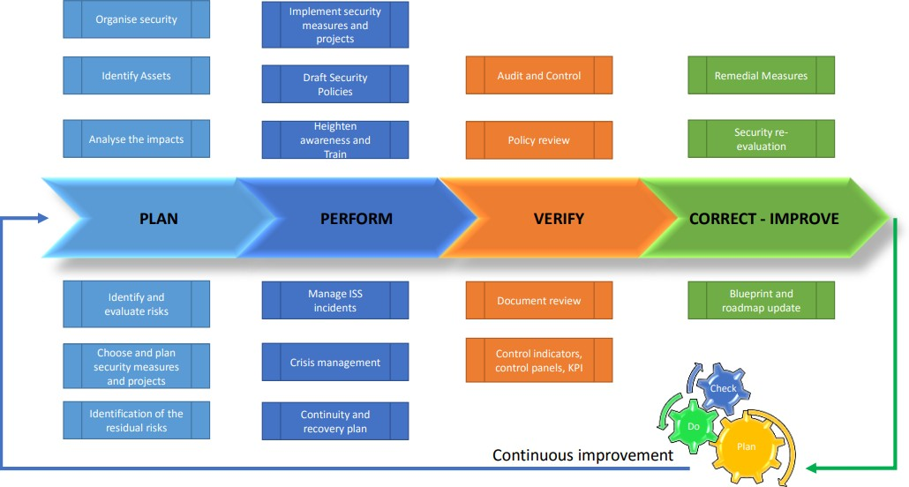

**Security Policies and Procedures**

The Services are operated in accordance with the following policies and procedures to enhance security:

* Customer passwords are stored using encryption.
* User access log entries will be maintained.
* If there is suspicion of inappropriate access, SSTL can provide customers with log entry records.
* Data center physical access logs, system infrastructure logs, and application logs will be kept for a minimum of 90 days. Logs will be kept in a secure area to prevent tampering.
* SSTL personnel will not set a defined password for a user. Passwords are reset to a random

value (which must be changed on first use)

**Intrusion Detection**

SSTL will monitor the Services for unauthorized intrusions using network-based and/or host-based intrusion detection mechanisms. SSTL may analyze data collected by users' web browsers for security purposes, including to detect compromised browsers, to prevent fraudulent authentications, and to ensure that the Services function properly.

**Security Logs**

All systems used in the provision of the Services, including firewalls, routers, network switches and operating systems, log information to their respective system log facility or a centralized syslog server (for network systems) to enable security reviews and analysis.

**Incident Management**

SSTL maintains security incident management policies and procedures. SSTL notifies CREST of significant system incidents by email, and for incidents lasting more than one hour, may invite CREST to join a conference call about the incident and SSTL response.

**User Authentication**

Access to Services requires authentication via Delegated user access, SSO integration will be implemented to all users if the SSO provider supports OpenID connect or LDAP. Crest users can login with SSO linked email ID while landlords can login with phone number or email address.

**Physical Security**

The infrastructure has access control systems that permit only authorized personnel to have access to secure areas. These facilities are designed to withstand adverse weather and other reasonably predictable natural conditions, utilize redundant electrical and telecommunications systems, employ environmental systems that monitor temperature, humidity, and other environmental conditions, and

interior and exterior surveillance cameras.

**Data Encryption**

The SSTL system architecture use industry-accepted encryption products to protect Customer Data and communications during transmissions between a customer's network and the SSTL will use SFTP, file transfer use SSH.

Smart Array Secure Encryption is used to secure the storage drive on the server in SSTL facility.

# Annexure A

For agreed upon data fields to be configured and captured for landlord, site and agreements refer to the attached document named “Crest_LMS_Data_Fields_v2.0.xlsx”.



# Annexure B

For the landlord data import template refer to the attached document named “Crest_LMS_Landlord_Data_Import_Template_v2.0.xlsx”.



# Annexure C

For the site data import template refer to the attached document named “Crest_LMS_Site_Data_Import_Template_v2.0.xlsx”.



# Annexure D

For the agreement data import template refer to the attached document named “Crest_LMS_Agreement_Data_Import_Template_v2.0.xlsx”.



# Annexure E

Following are the list of common rejection reasons provided by Crest to be used during Agreement approval workflow task execution.

| **Sr.No** | **Rejection Points on Agreement onboarding** |
| --- | --- |
| 1 | Rent amount mismatch in agreement with RCC and NFA |
| 2 | Mismatch in MRFAI date and OpCo approval |
| 3 | Documents not signed and stamped by Crest/Builder |
| 4 | Difference amount in NFA & Agreement |
| 5 | As per DOA, approval missing for first rental process |
| 6 | Wrong operator mention in NFA/RCC |
| 7 | Builder name mismatch in Agreement, KYC, Bank Details, PAN, GST RC |
| 8 | Affidavit / Letter duly signed & stamped on Name Mismatch in PAN, Agreement, Bank Details (Cancelled Cheque) not shared |
| 9 | Date mismatch in RCC and NFA |
| 10 | KYC mismatch and correction required |
| 11 | Management Approved NFA (Note for Approval) not shared |
| 12 | Agreement (Both Party Signed & Stamped) not shared |
| 13 | Both party signed & stamped on RCC (Rent Commencement Certificate) not shared |
| 14 | Property Documents not shared/ missing |
| 15 | Property Documents not duly stamped/ notarized/ registered |
| 16 | Updated address not mentioned in the Property documents. |
| 17 | Latest landlord's electricity bill not shared |
| 18 | Landlord's electricity bill has arrears |
| 19 | Landlord signoff on maintenance charges not shared |
| 20 | Duly stamped affidavit for name changes not shared |
| 21 | Landlord NOC for site installation |
| 22 | Landlord NOC for own EB Connection not shared |
| 23 | NOC from all the co-owners, wrt the payment of rent, not shared |
| 24 | NOC from owner to transfer to any other beneficiary |
| 25 | Legal Heir Certificate/Death Certificate |
| 26 | Duly stamped affidavit cum indemnity bond not shared |
| 27 | Legal vetted latest template not used |
| 28 | Both party authorized signatory details not updated |
| 29 | Owner signature missing on all the pages of the Agreement |
| 30 | Owner signature miss-match on all the pages of the Agreement |
| 31 | Approved NFA not shared for any document deficiency |
| 32 | Approved NFA not shared for any agreement clause deviations |
| 33 | Both parties self-attested documents not given including Agreements, Addendum and other forms. |
| 34 | MSME Confirmation / Certificate |
| 35 | GST RC |
| 36 | Cancelled Cheque / Bank Passbook not provided |
| 37 | PAN not provided |
| 38 | KYC signoff Form not shared |
| 39 | Valid Invoice with Correct GST number & address |
| 40 | Realtor’s / Owner’s TDS Declaration |
| 41 | Area signoff documents pending from Operator |
| 42 | Area signoff documents pending from Landlord |
| 43 | MRFAI Acceptance document (OPCO) not shared |
| 44 | Documents not visible |
| 45 | Other(If any) |

# Annexure F

Following is the trouble ticket type wise list of issue/query categories provided by Crest.

|  |  |
| --- | --- |
| **Trouble Ticket Type** | **Subcategory** |
| Agreement | Addendum Agreement |
| Agreement Renewal |
| Ownership Change |
| Termination |
| Tenant Exit |
| Others |
| Financial | Statement of Account |
| Bank Guarantee |
| Arrears |
| Demand note |
| EB / DG |
| Escalation |
| First Documents |
| Interest |
| KYC |
| Maintenance |
| Municipal Corporation Tax |
| Reconciliation |
| Rental |
| Security Deposit |
| TDS |
| GST |
| Others |
| Operation | Public Issues (Force Majeure) |
| Ingenuine Demand (Force Majeure) |
| Termination (Force Majeure) |
| Safety |
| Civil |
| Network complaint |
| Infrastructure |
| Electrical |
| Others |
| Project Vidyut | Own EB Connection |
| Others | Others |

# **HLD Sign Off**

|  |
| --- |
| HLD Doc Ref No: LMS_High_Level_Design_Crest_v1.3 Final |
| Name Of PIC  Designation:  Signature:  Date |
| Name Of PIC  Designation:  Signature:  Date |